This Case Assignment will assess your knowledge of: Organizational Change, Organizational Strategy, Communication, and Work & Well-being. Read the case article, answer the following questions using the knowledge from course materials.

Tips: I just highlighted the key terms and provided the page number of those terms appeared. Please read the related course material and give fully analysis of each question.
CASE: ART HANG-UPS.
Jenny Deacon had managed numerous successful art shows at Teller & Shinsky Gallery – a venue for modern, contemporary works. A five-part exhibit titled “When the Lights Go Out,” was on her mind. She was thinking of admitting a series OF watercolors into the third part of the exhibit but wasn’t sure if the medium would strike the right tone.
“Is everything alright?” asked Brandon, who had a hand in finalizing selections for each part of the exhibit since its inception.
“I’m not sure about this. What do you think?” She gestured for him to take a look at snapshots of the watercolors, and studied his face. Instantly, Brandon’s eyes narrowed and Jenny felt ashamed for asking. “When the Lights Go Out” was supposed to be Brandon’s break-out exhibit. He had been working with Jenny for 4 years and in the last year, they agreed that she would hand over more responsibilities to her protégé so that she could have a heavier hand in the museum’s long-term strategy and building relationships with patrons. The exhibit however, meant so much to Jenny: she had lobbied for the exhibit in the first place, reached out to artists that were perfect for it, and found sponsors for it. They were two parts in and Part 3 was pivotal for creating the necessary emotional tension leading up to the conclusion (Parts 4 and 5).
Brandon crossed his arms, “Decisions are due tomorrow morning, 7am.”
Both Jenny and Brandon looked up at the digital clock on the wall: 6:00 PM. Jenny spent majority of her day meeting donors, handling the “Jade(d) Eyes” exhibit – a recurring show featuring art by environmentalists, and she had to attend a dinner meeting to finalize a major sale that would fund the gallery’s next three exhibits. Jenny only intended to thumb through the “When the Lights Go Out” file, to sign-off on the selections. But to resolve her indecision, she’d have to return to the office and sacrifice her evening. She had hoped to spend the night looking over a new idea: a Native American jewelry exhibit, something totally new and exciting for her. She knew that such an exhibit wasn’t a natural fit at Teller & Shinsky, but the more she met with the artisans, her commitment to the idea grew. Unfortunately, her duties at the Gallery saw her putting in 14 hour days and that left very little time to make headway on this new idea.
“I’ll look at this later on,” she sighed.
Brandon shrugged, “‘Jenny wizardry’ is at it again.”
Jenny rolled her eyes and muttered, “Whatever.” Clara Shinsky, one of the owners had first used those words in a staff meeting applauding Jenny’s success at finding the latest and greatest works, and the words stuck. Indeed, Norm Teller (Clara’s partner) insisted that they be printed in exhibition catalogues, and even other gallery owners, directors, and artists often referenced her “wizardry” at events. Jenny was flattered that her talent was so well-known, but she also felt like her light was slowly fading out. The demanding schedule and variety of projects was stretching her thin. It almost made her cry when she heard people ask, “Did Jenny Wizardry touch this?”
A HEATED CONVERSATION
At the dinner meeting, Jenny’s phone vibrated. She looked down and saw texts from the Gallery’s art advisors, all of them fretting over the lackluster numbers for Part 2 of “When the Lights Go Out’” last week. She quickly typed, “We will see more traffic when the weather lets up.” And then, a barrage of opinions from the advisors flooded her phone:
“Brandon needs wizardry badly.”
“He’s not ready to take the reins.”
“Weather is a poor excuse.”
Then Clara chimed in, “How’s part 3 shaping up? I hope you are going to be more involved this time; this is critical.”
Jenny excused herself politely from the dining table and called Clara to respond, “I got your message. I’ll be in the office tonight to talk with Brandon. But remember, I’ve grown my responsibilities in other areas like meeting with patrons and strategic planning, and so I can’t oversee the same number of exhibits like before. I barely find time to eat and sleep. Brandon is essential to taking the reins on ‘When the Lights Go Out’ and I would like to give him even more leadership next year.”
Clara did not miss a beat, “That’s not going to happen. ‘When the Lights Go Out’ needs saving. It needs 100% from you.”
Jenny huffed, “Well then, maybe we’ll have to think about putting off some of our exhibits till next year, and looking even more long-term, I’d love to see us move from 10 to 6 exhibits a year, and feature fewer artists at each exhibit. Those are the sorts of changes that would really help me keep pace.”
Clara sounded miffed, “Jenny, you successfully showed 10 exhibits last year, we won a national award, and secured a dozen new donors. While other galleries are struggling, we are not. I can’t propose that we cut back on exhibits and artists. No one would take me seriously, and Norm might even re-think our partnership if I come to him with such a ridiculous idea. Actually, he’d probably have a hearty laugh at my expense before asking me if my head was screwed on.”
Jenny didn’t budge, “If you want me to excel in all aspects of my job, I need time.” She could anticipate Clara’s next argument, “I know that typically, things slow down in winter, but I cannot effectively conduct the amount of research and preparation required of me into that one season and take on the new responsibilities which you agreed were critical to my development.”
Clara sounded apathetic on the other end, “Look, you are a dedicated employee who truly wants what is best for our Gallery; that is why you will never completely detach yourself from any of the exhibitions. I think deep down, you know that you don’t want to hand over the reins to Brandon.”
Jenny’s shoulders slumped. She didn’t want to admit it, but Clara was correct: she put her heart and soul into all of her exhibits and giving them to someone else was painful. Finding an excuse not to concede, Jenny mumbled, “I better go, Clara. I have to wrap up dinner.”
“Wait,” Clara said, “I heard through the grape vine that you’re considering a jewelry exhibit?”
“What?” Jenny wasn’t sure how to respond, “I’d like to think that I always have something in the works. But as of right now, I’m pretty tied up with our current line-up.” She didn’t want to sound shifty but she wasn’t quite ready to pitch anything; she was still contemplating if Teller & Shinsky was the appropriate venue for a jewelry showcase. In the past, she’d sprint to Clara and Norm with new ideas, and for the most part they were supportive and asked the challenging questions that ultimately, led to superior results. But what if the jewelry artisans suffered because she lacked the courage to pitch the show to a more suitable gallery? Jenny thought that an ideal venue for a Native American jewelry exhibit would be Gen.e.vieve, the up-and-coming all-female gallery whose mission included acting as a voice for disenfranchised members of society.
Jenny did not dare to explain to Clara that she’d like to reduce her workload so that she can plan an exhibit that would be perfect for a competing gallery. She also pushed aside her doubts about the jewelry exhibit altogether: What if it is too kitschy and tanks? There was a voice in her head saying, “Just endure the workload and ride your wave of success at Teller & Shinsky.”
IN OR OUT?
Jenny replayed her conversation with Clara all the way back to the office. The buzzing of her phone interrupted her thoughts; it was a text from Brandon: “@ office lounge”. She was exhausted but wanted to talk to Brandon. If they could come to a final decision, she had a good chance of getting sleep that night.
“Sorry I couldn’t get here earlier,” she said.
“That’s okay,” Brandon replied, “I took some time to consider the watercolors. I think your indecision is helping me realize that their inclusion offers an element of surprise and they’ll truly be unexpected. For the viewer, the mental work that it takes to get over that surprise, discomfort or whatever you feel, is a big reason to come to the show.”
Jenny gave Brandon a hug, “I promise that this is going to get easier for you – for us.”
Brandon shrugged, “Jenny, I can’t be you. These exhibits have your name written all over them and it’s hard, if not impossible, to manage them without running to you.”
Jenny sighed, “Brandon, be yourself. You have the chops.”
A CHANCE MEETING
The next morning while Jenny was waiting in line for a bagel and coffee, Abby Sussman, one of the new art agents at Gen.e.vieve bumped into her.
“Jenny, is that you?”
“Abby? Yeah, it’s so good to see you again. I heard you just joined Gen.e.vieve.”
“That’s right. It’s been a crazy ride. We should grab lunch or something soon. I just met with some incredible women from Ghana. Part of their art is actually watching them create – it’s almost more beautiful than the end product.”
Jenny’s eyes widened, “Sounds incredible. Did you just get back from Ghana?”
“Last night,” Abby grimaced. “I thought I’d be a mess after the travel, but it was transformative, ya know? I kind of feel bad though about how much the entire excursion cost the gallery, but the Board kept pushing the visit, telling us that we need to take more risks if we want to make an impact.”
Jenny nodded, “That’s really awesome.”
“You know what? You have to meet our owners – they would love to hear what you think of some of our ideas,” Abby said excitedly. “Let’s face it, you are one of the most successful women in this space, Jenny. Anytime you can make for Gen.e.vieve would mean a lot. I’m sure Teller & Shinsky have you –“
Jenny interrupted, “Well, no one has me.”
Abby looked pensive, “If you are looking to do something a little different, we should talk more. I think there will be countless ways for us to blend our creative juices and push some boundaries.” Abby handed Jenny her card.
Jenny wasn’t sure if it was the lack of morning caffeine but something made her freeze. She wanted to blurt out that she had a cool idea that she thought would be perfect for Gen.e.vieve and that she wanted to talk about it right this second…but she was due for a meeting with Norm and Clara in half an hour.
Early in the afternoon, Jenny let out a giant sigh at her desk while creasing a corner of Abby’s card. It wasn’t far into the day and she already felt like she was running low on energy. She knew that she had to give Brandon increased responsibility, just like they agreed, or she would have to figure out a way to decrease the demanding exhibit schedule that Teller & Shinsky were committed to. She tried to tell herself that any financial hit and bad press would just be in the short term. Or perhaps she should just halt any momentum on the jewelry exhibit? When things slowed down at work, she could revisit it.
Before she could contemplate any further, her phone pinged: the watercolors had just arrived.
Question 1: (page 73-74 and the video)

Under the section, “A Heated Conversation” Clara and Jenny have a conversation about Jenny's struggles. Clara’s responses to Jenny are indicative of her emotional intelligence. If you had to rate Clara on a scale from 1 (poor emotional intelligence) to 5 (a great deal of emotional intelligence), where would you rate her? Justify your rating and in doing so, clearly demonstrate your understanding of emotional intelligence and what emotionally-intelligent behavior looks like.

Question 2: (https://youtu.be/qf1ZI-O_9tU)

Brandon is supposed to inherit "When the Light Go Out" from Jenny, but we learn in the case that handing over the reins to Brandon is challenging. See the figures below for where the USA lies on each of Meyers’ culture map dimensions; we can assume that this case takes place in the USA. Choose one of Meyers’ dimensions to explain why leadership succession is challenging in this case. In your answer, make sure your understanding of the dimension you chose is clearly explained.
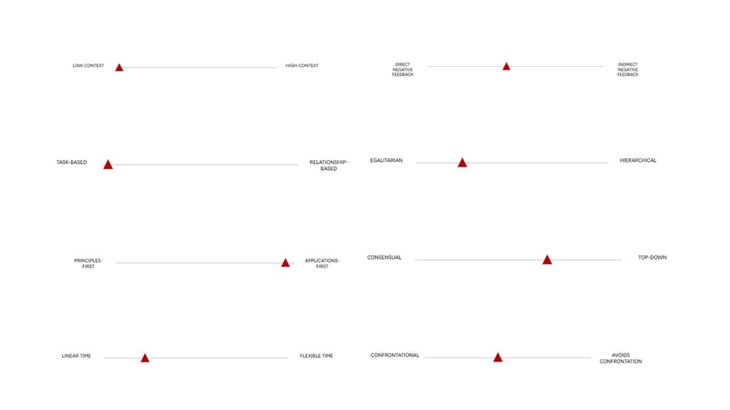

Question 3: (page 55-72)

Those are two instances that contribute to Jenny's stress: (1) arguing with Clara over Brandon's increased involvement in "When the Lights Go Out" and (2) working in a struggling industry. Knowing the four categories of different work stressors from class (four categories of work stressors: interpersonal, role-related, task-control, and organizational/physical environment), to which category or categories do these stressors belong? In your answer, clearly link each stressor to the category of your choice and provide an explanation for your choices so that your understanding of the category/categories that you chose is clear.

Question 4: (page 55-72)
As a friend to Jenny, you might hear her complaints about Clara's lack of understanding and suggest that Jenny talk to Norm about her frustrations with Clara; and you could also suggest that Jenny talk to Abby about her frustrations with Clara. Given the two categories for managing stress (primary and secondary), to which category or categories do these stressors belong? In your answer, clearly link each suggestion to the category of your choice and provide an explanation for your choices so that your understanding of the categories is clear.
Question 5: (page 9)

Jenny has a new: a Native American jewelry exhibit. If this exhibit were to take place at Teller & Shinsky, would it be a risk-seeking or risk-avoidant strategy for the gallery? Explain your choice and in doing so, ensure that your understanding of risk-seeking and/or risk-avoidant strategy is clear.

Question 6: (page 25)

Jenny suggests to Clara, “[M]aybe we’ll have to think about putting off some of our exhibits till next year, and looking even more long-term, I’d love to see us move from 10 to 6 exhibits a year, and feature fewer artists at each exhibit.” Clara resists Jenny's suggestion. Guided by the lessons learned so far, should Jenny treat this as an issue of managing resistance to change or an issue of persuasion? Make a clear choice between these two approaches, and when justifying your choice, be clear about when an individual should use one or the other.

