Use the map below to show the countries involved in the two great military alliances that contributed to the outbreak of World War I. The two alliances were the "Triple Entente" and the "Triple Alliance."
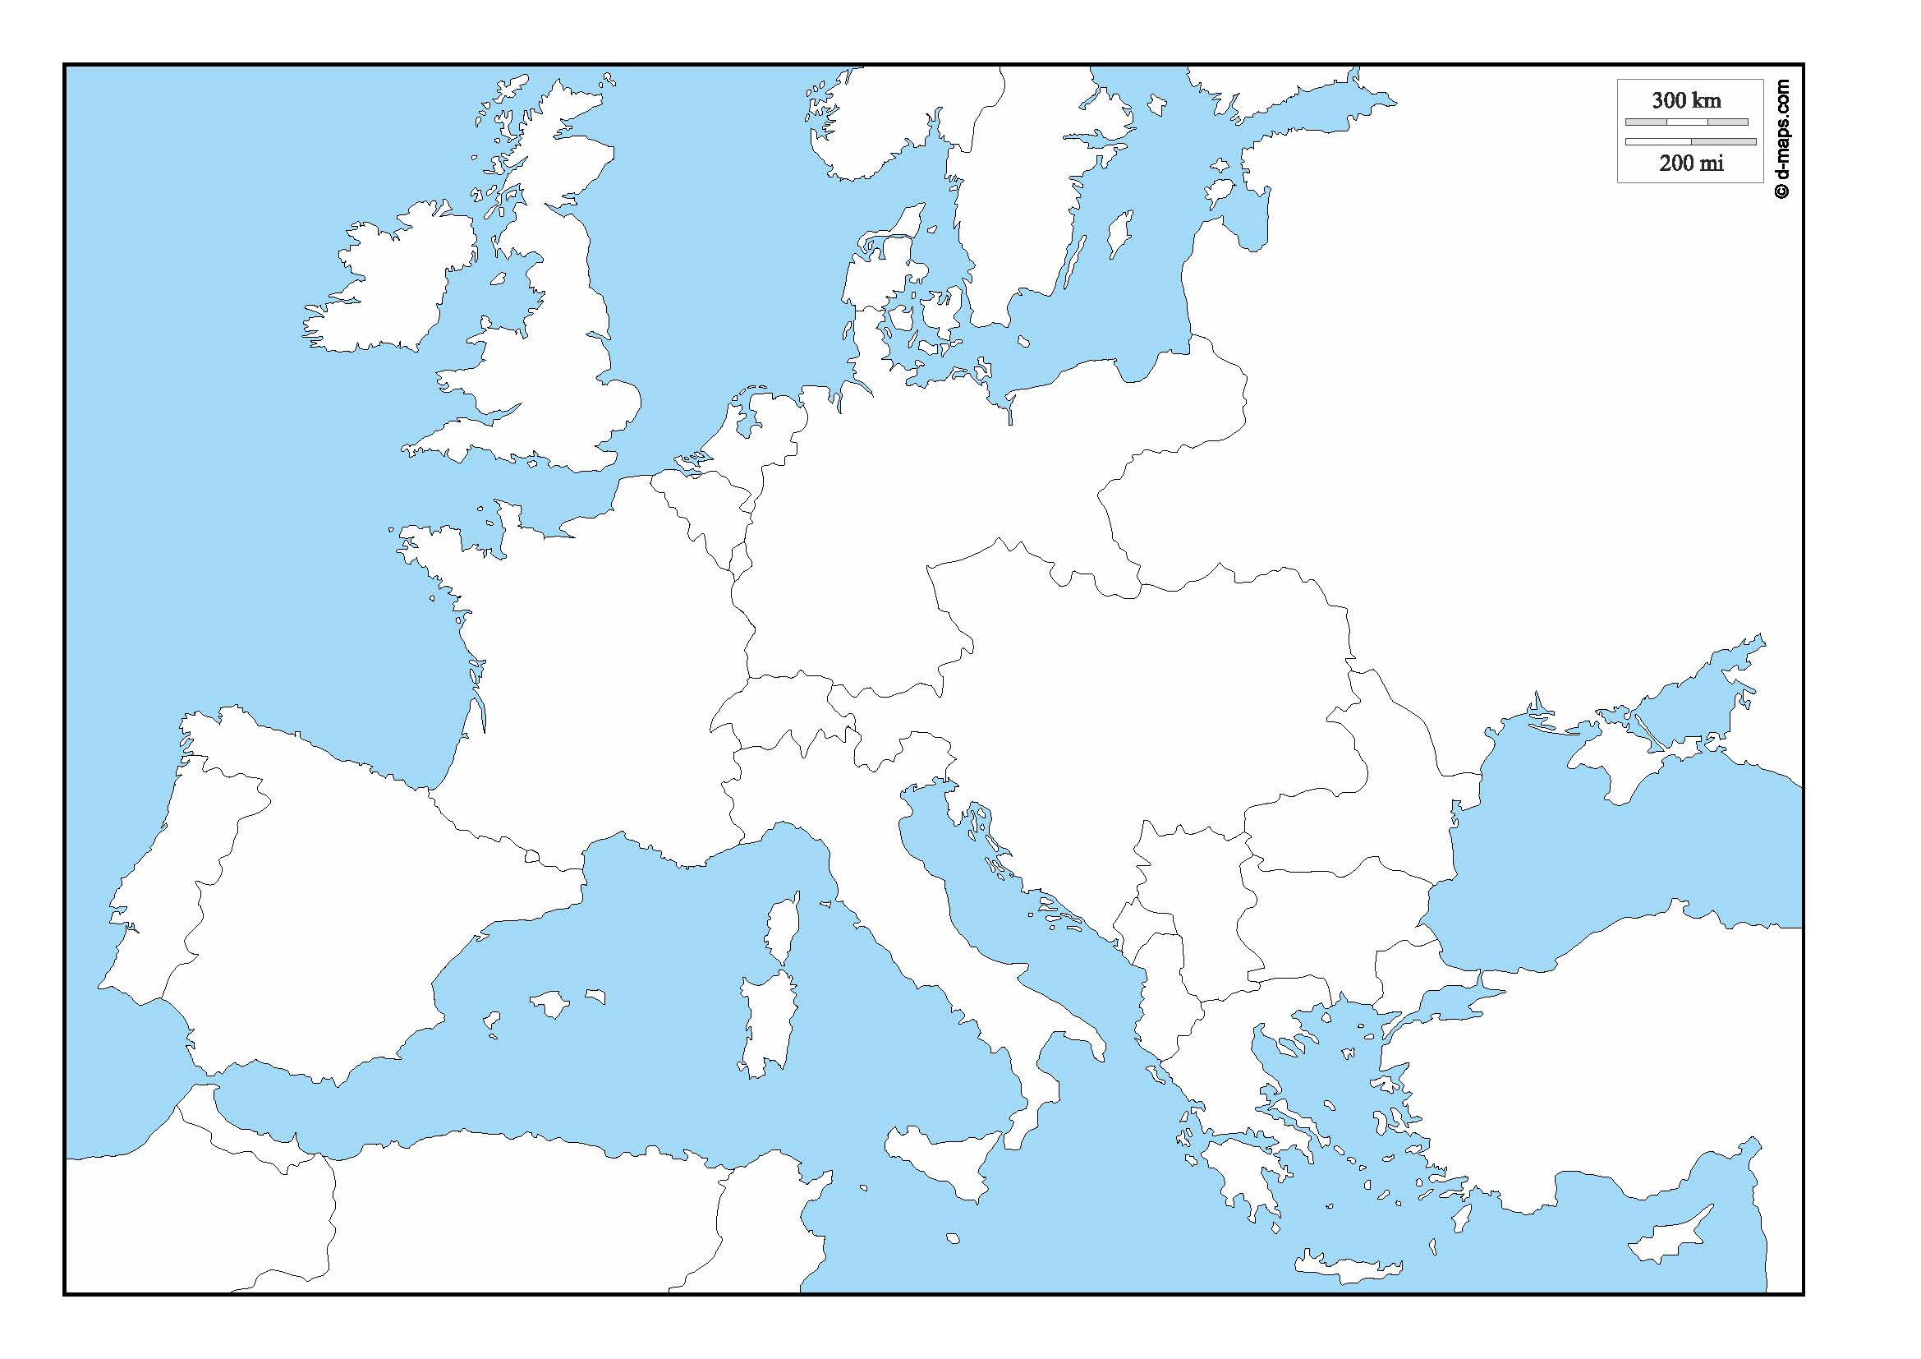
In addition, in a page or so, explain the events involving these allied countries that led to the outbreak of war in 1914.

