Terry Elliott
Dr. Hagaman
English 300
April 24, 2019
An Editorial Cartoon Analysis: Shame on Who?
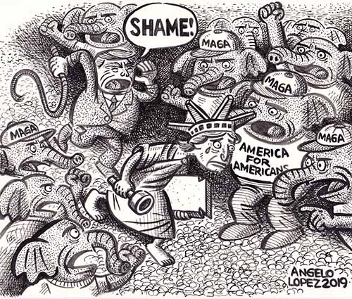
Trump, Immigration and the Republican Party

American political cartoonist Angelo Lopez published this cartoon in the April 24, 2019 edition of
Phillipines Today. Lopez is an illustrator who has published in Tikkun Magazine, the Palo Alto Daily News and Z Magazine as well as the New Yorker. Lopez usually focuses on drawing about strictly Fillipino issues, but this time he goes after the larger issue of immingration under the Trump administration. He is definitely not happy about the attitude of the American president and his followers.
There are many ways to analyze a political cartoon. My method is one I developed as a media humanities teacher in high school. It consists of three basic “moves”: text, context, and subtext. Once analyzed this way, the cartoon’s meaning becomes clear to those for whom it was a mystery at first.The first step is to examine the “text” of the cartoon. I am using the word text in a larger sense. Of course, the text includes the caption and any words within the frame of the cartoon, but it also included everything else within that frame. The assumption we make is that the artist put everything in the frame for a reason so we should observe and acknowledge that. Often the cartoon can have a subtle meaning that relies on our having looked closely at every graphic element within.
The second step is to explore the context or what is outside of the frame of the cartoon. What we mean by outside is this: every cartoon has some kind of triggering event. These can be general or specific. These events have caused the cartoonist to take a particular stand in order to convince you to agree with him or her. For example, there have been many editorial cartoons of late about the bombing of churches in Sri Lanka and the burning of the Cathedral of Notre Dame. Cartoonists take this context and situate their cartoons within them to make an argument. This step requires the reader to fill in some of the blanks, perhaps even to explore a little more especially if they are not quite sure about the context. In the example above from Sri Lanka I had to do some general research about Sri Lanka in order to understand the religious tension between Christians, Buddhists, and Muslims in that country and what specifically triggered the attacks. Once this is done, it is much easier to move toward understanding the cartoonist’s larger meaning, his subtext.
The third and last step is to state the cartoonist’s subtext. In other words, I need to explain the meaning of the cartoon in light of the context and text. This requires us to analyze what the ultimate purpose of the cartoon. It, also, forces you to decide where you stand. Do you agree, disagree, or both? It is often easy to jump to a conclusion right away in one glance. Sometimes we are right. The idea behind this three step protocol is to make sure we are right. Or at least as sure as we can be.
If you analyze the editorial cartoon at the beginning of this essay you will find that at first sight this is a simple comment on President Donald Trump’s immigration policies. There is a simple message but there is also a deeper and more powerful global message as well as a very specific one for the Phillipines.
[Text: “Shame”, “ America for Americans,” Trump is saying shame and he has a whip. Elephants with MAGA hats, Lady Liberty being assaulted between the MAGA hatted elephants. Trump is driving Lady Liberty away. Elephants are shaking fists and pointing at Lady Liberty. She is in bare feet. Elephants have shoes. Lady Liberty is crying. She carries a torch and a stone tablet. Dark hatching by the artist focuses our attention on Trump and his whip. Trump caricature, screaming shame, they are all driving her away to somewhere else.]
[Context: Trump immigration policy—no more room. MAGA hats “make American Great Again”. The US is a nation founded on immigration and now what—get them out of here. Lady Liberty as a symbol of acceptance. The poem on the Statue of Liberty. Trump and his followers are driving out the longstanding value of sanctuary for the afflicted. Phillipine President DuTerte has a similar policy. Famous for his drug death squads, Trump supported DuTerte’s murdering of drug users and sellers.]
[Subtext: Angelo Lopez argues in his political cartoon that Trump’s presidency, his xenophobia, his deportation policies, and his racist statements about those from other countries has resulted in the “deportation” of Lady Liberty by the President and his MAGA-hatted supporters. I, also think that Lopez is making a sly slap at Phillipine President Rodrigo Duterte’s drug death squad policies that are supported by Trump. The hidden message to Americans is this: if Americans let Trump whip out the immigrants and whip them away from US borders, then who knows what may happen next? Nothing good, that is for sure.
I am certainly reminded of Holocaust survivor and Lutheran pastor, Martin Niemöller’s poem
First they came for the socialists, and I did not speak out—
Because I was not a socialist.
Then they came for the trade unionists, and I did not speak out—
Because I was not a trade unionist.
Then they came for the Jews, and I did not speak out—
Because I was not a Jew.
Then they came for me—and there was no one left to speak for me.

I don’t believe that Lopez’s dark message is a certainty, but it is certainly within realm of possibility. I think that, as Hannah Arendt wrote, “All that is necessary for evil to triumph is for good men and women to remain silent.” In this I believe Lopez’s message is too true to ignore.

Works Cited
AAEC - Angelo Lopez Cartoonist Profile. http://editorialcartoonists.com/cartoonist/profile.cfm/LopezA. Accessed 24 Apr. 2019.
Lopez, Angelo. “Trump, Immigration and the Republican Party.” AAEC: The Association of American Editorial Cartoonists, AAEC, 24 Apr. 2019, http://editorialcartoonists.com/cartoon/display.cfm/176914/.

