Academic Affiliation with California State University – Northridge

Department of Business Administration
Continuous Assessment -2
Second Semester 2019-20

Course Code : MGT 201
Course Name : Human Resource Development
Course Instructor : Mr. Syed Kaleemullah
Date : 26 April, 2020
Section : 3
Student's Name : ………………………………………………………………………..
I. D. Number : ………………………………………………………………………..
Question No. | Marks Obtained |  |  |  |  |  |  | Maximum Marks | Comments if any
 | O1 | O2 | O3 | O4 | O5 |  | O6
 |  |  | 15 | 15
1 |  |  |  |  |  |  |  | /15
2 |  |  |  |  |  |  |  | /05
3 |  |  |  |  |  |  |  | /10
Outcomes Total |  |  |  |  |  |  |  | /30
Total Marks(in figures)
Total Marks(in words)
Evaluator’s Signature

Remark: Candidates are advised to read all instructions before answering.

Objectives: The following student learning outcome of the course in this continuous assessment tool:
SLO3. Illustrate the recruiting process and different sources of recruitment.
SLO4. Analyze in detail selection process along with its criteria.

Description of the Tool:
Read the lecture notes /and case carefully, identify problems and issues in scenario and respond to specific questions you have been asked.
Purpose: The purpose of this assignment is to familiarize students with recruitment & selection procedure.

Individual Assignment
Assessment Weighting: 30%
Submission Date (s): 5th May, 2020
Assessment Weighting: 30%
Plagiarism Policy
“Plagiarism is using someone else’s work, in whole or in part, as one’s own without crediting or citing that source properly. It also occurs if the permission has not been obtained from the author to use his or her work. It includes all electronic sources, all printed and written sources; and all verbal sources. In BUC sharing one’s work with other students is also considered an act of plagiarism. Plagiarism can lead to punishment ranging up to giving grade (f) in the course or dismissal from the college”
Submission Instructions
- Use A4 size paper
- Use Times New Roman 12 font size with double (2) line spacing
- Use first page of assignment as cover page to submit your work
- Multiple pages must be stapled at top left corner
- Late submission is subjected to deduction of 2 marks per delayed day
- Student will be awarded zero grades and served with academic warning in case of submitting plagiarized work

SECTION-A (5 x 3= 15 Marks)
Question No. 1:
Note: Answer any FIVE questions
1. Define recruitment. List the factors that affect recruitment. (03 Marks)
2. Describe different sources of recruitment. (03 Marks)
3. What specific constraints might prevent an HR manager from hiring the best candidate? (03 Marks)

4. Identify three important variables that affect response rates to job advertisements. (03 Marks)
5, Describe the benefits of online recruiting. (03 Marks)
6. Explain briefly steps involved in selection procedure. (03 Marks)
7. Why should HR manager conduct a background investigation? (03 Marks)
8. Explain the purpose of stress interview. (03 Marks)

SECTION –B
Question No. 2:
Case Study 1:
Read the case carefully and answer the following questions. (5 Marks)

What a Fraud!
The economy is tight, and there is competition among applicants to land jobs. This setting is expected to lead to an increase in the number of applicants who will misrepresent their background and credentials. The hope, of course, is that this bit of fudging will help them get the job. The misrepresentations might involve a change in the date of birth, shifting a college major, or maybe even the fabrication of a degree. There may also be lies about criminal records. The fact of the matter is that these misrepresentations, whether “little white lies” or major fabrications, are fraud. It is expected that fraud will be engaged in by approximately 30 percent of job applicants.

Questions:
1. Do you think fraud on resumes and job applications is an important issue for organizations? Why or why
not? (02 Marks)
2. In some countries, fake qualification and forged certificate are as common as the real thing. To what extent
do you think this devalues the real thing? (02 Marks)
3. If a fraudulent imposter can perform the job, what’s the harm? (01 Marks)
Question No. 3: (10 Marks)
Case Study 2:

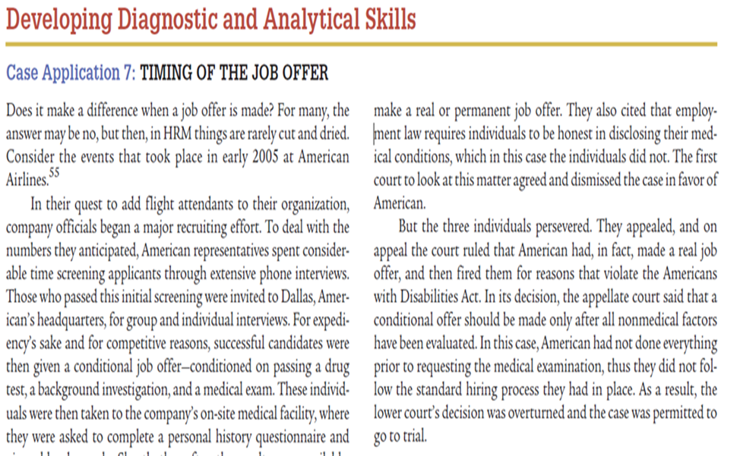
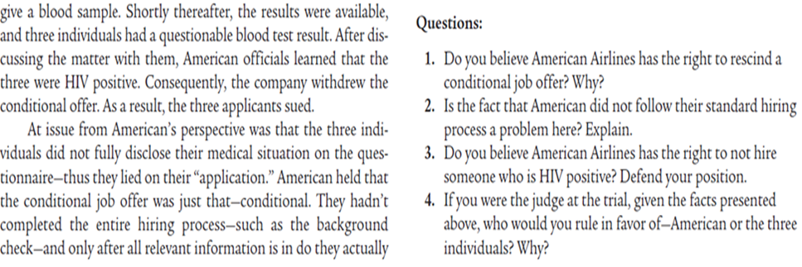

END OF ASSIGNMENT

