Case 3 Avon
Introduction
Avon Products, Inc. is the world’s largest direct seller; it markets beauty, fashion, and home products to women in more than 100 countries through approximately 6.4 million active independent sales representatives.1 Having previously enjoyed great success as a leading global beauty company, the company is now facing an array of issues. In response, in December 2011, Avon Products, Inc. announced that its CEO and Executive Chairman – Andrea Jung – would step down from her position as soon as her replacement was found. Over the two years prior to the announcement, Avon’s share price had decreased by more than 50 percent. The company was also facing bribery charges in some of its overseas operations as well as an SEC investigation into whether an Avon official made confidential comments to an analyst.2 Clearly, Andrea Jung’s replacement would face many challenges.
History
While working as a traveling book salesman David H. McConnell discovered that women were much more interested in the free perfume samples he offered than the books he sought to sell to them. This prompted him to create The California Perfume Company in 1886, later to be renamed Avon Products, Inc. Aware of the fact that many women were at home while their husbands were at work and with the belief that they could relate to other women and help network, market, and sell his products, McConnell decided to offer these women a commission for selling his products. In essence, he offered women the opportunity to create and manage their own direct- selling businesses. And with that simple brainstorm, “The company for women” was on its way to selling beauty products and empowering women throughout the world.3 According to Avoncompany.com, direct selling at Avon “connected women, who were otherwise isolated and immersed in domestic life, in what the company calls ‘the original social network.’” Through Avon, women could sample and purchase beauty products without having to travel miles to the nearest department or drug store. By focusing on personal relationships, Avon’s sales exceeded $1 million by 1920, $1 billion by 1972, and
$10 billion by 2008.4 As an increasing number of women entered the more
traditional workplace, Avon made adjustments. In the 1970s, the firm developed a brochure with samples that could be left on the doorknob of an unoccupied home. In 1986, Avon began selling within the workplace in addi- tion to homes. Beginning in the 1990s, representatives could earn money not only by selling, but by recruitingand training representatives as well. Shortly thereafter, Avon integrated Internet access into the arsenal of rep- resentative’s tools.5
Avon has a history of working with celebrities to market the brand. Beginning in the 1940s, Avon’s products were endorsed by Rosalind Russell, Loretta Young, Claudette Colbert, Joe DiMaggio, and Jimmy Stewart. More recent celebrity endorsers include Fergie, Salma Hayek, Zoe Saldana, Ashley Greene, and Patrick Dempsey. Cher, Billy Dee Williams, and Catherine Deneuve market fragrances through Avon and Reese Witherspoon serves as the firm’s Global Ambassador.

Products and Brands
Avon’s products include cosmetics, skincare, fragrance, personal care, hair care, and jewelry. Additionally, Avon

carries various brands. “mark.” is a brand that includes fashion, accessories, scents, and color pallets geared toward the younger generation. “Liz Earle” is a skin- care line that uses natural active ingredients. Since 2010, Avon has owned “Silpada,” which is the largest and fast- est-growing sterling silver jewelry home party company. Avon also offers products for mothers and their babies including toys, bath, and clothing products for babies as well as beauty “must-haves” and accessories for mom.7 Though Avon directs most products toward women, it offers men’s products as well including a body wash and fragrance endorsed by Derek Jeter.
Vision, Mission, and Values
Vision: “To be the company that best understands and satisfies the product, service and self-fulfillment needs of women—globally.” Mission: Avon has a six-point list of aspirations that the company strives to achieve:
■■ To be a leader in global beauty ■■ To be women’s choice for buying ■■ To be a premier direct-selling company ■■ To be a “most admired” company ■■ To be a “best place to work” ■■ To have the largest foundation dedicated to women’s
causes.8
Values: Founder David McConnell felt it was beneficial to provide a supportive and “family-like” environment, even naming the company newsletter the “Family Album.”9
Avon continues to focus on the five values and seven guid- ing principles he implemented. The values include trust, respect, belief, humility, and integrity, while the principles include the opportunity to earn [money], serve families by providing high quality products, render outstanding ser- vice, fully recognize employees and representatives, share rewards with others, meet obligations of corporate citizen- ship, and maintain and cherish the friendly spirit of Avon.10
Outside the Company
Avon Products, Inc. is a global firm. According to the firm, its “International operations are conducted pri- marily through subsidiaries in 64 countries and terri- tories outside of the U.S. In addition to these countries and territories, [Avon’s] products are distributed in 42 other countries and territories.”11 Avon generates 83 per- cent of its consolidated revenue from outside the United States (see Exhibit 1). The 2008 financial crisis resulted in increased unemployment, tightening of credit mar- kets, and the failures of financial institutions, all of which negatively impacted the global economy. As a result, consumers had less income to spend on “discretion- ary items, such as beauty and related products,” which negatively affected Avon’s product sales. Avon faced con- tinued economic challenges in fiscal 2012 because con- sumers continued to struggle with increased “job losses, foreclosures, bankruptcies, reduced access to credit, and sharply falling home prices, among other things.”12
Because 83 percent of consolidated sales are of inter- national origin, fluctuations in exchange rates pose a

itical risk for Avon. For the majority of Avon’s interna- tional operations, the local currency is used as the func- tional currency. As a result, exchange rates have a sig- nificant impact on Avon’s earnings, assets, cash flow, and financial position. To mitigate the risk of exchange rate fluctuations, Avon “implements foreign currency hedg- ing and risk management strategies to reduce exposure to fluctuations in earnings and cash flows.”13
In addition to currency fluctuations, Avon is vulner- able to the policies of foreign governments in the coun- tries in which it operates. Notably, Avon faces currency transfer restrictions in Venezuela as the Venezuelan government has been implementing and intensifying currency restrictions since 2003. At present, Avon’s sub- sidiary in Venezuela is unable to exchange local currency for USD through the government. As a result, Avon is forced to use a third party to exchange the currency, which burdens it with an increased cost to obtain all imported products necessary for production.
Lastly, Avon initiated an internal audit in 2008 to investigate its compliance with the Foreign Corrupt Practices Act (FCPA) and related U.S. and foreign laws, specifically with China. In October 2011, the U.S. Securities and Exchange Commission (SEC) subpoenaed financial documents from Avon and officially ordered an investigation of any violations to the FCPA.14 According to the New York Times, “the legal fees and costs for out- side counsel conducting the internal investigation totaled $59 million in 2009 and $95 million in 2010.”15 It is esti- mated that Avon will spend $250 million total for the internal investigation, not including any fines the com- pany may incur. The Justice Department and SEC will rely on the findings from Avon’s internal investigation to determine a resolution.16 Avon has already incurred a serious financial loss for this investigation and is at future risk if found in violation.
Competitive Fronts
Avon faces competition in both the United States and international markets. In addition to the products themselves, Avon competes with companies based on direct-selling strategies, Internet, and the mass-market channels of retail. According to the firm, “Within the direct-selling channel, we compete on a regional and often country-by-country basis, with our direct-selling competitors.”17 Several direct-selling companies includ- ing Mary Kay and Arbonne sell product lines similar to Avon and have international operations to compete with Avon globally. Aside from Mary Kay and Arbonne, Avon competes with other beauty companies using a distinct
business model that relies heavily on the success of its representatives. To ensure it can continue to hire quality representatives, Avon competes with other direct-selling companies to provide the best earning opportunities. Avon believes its representatives are just as essential as the development of innovative products. In essence, Avon competes on two fronts: recruiting quality repre- sentatives first and the sales of beauty products second.
“Within the broader Consumer Product Goods (CPG) industry, Avon competes against large and well- known cosmetics and fragrances companies such as L’Oréal and P&G that manufacture and sell broad prod- uct lines through various types of retail establishment.”18 The beauty industry is highly competitive. Companies such as L’Oréal and P&G generate higher sales volume and have larger resource portfolios compared to their competitors, including Avon.
The beauty segment of Avon’s business generates the majority of its revenue. In 2012, the beauty business gen- erated 73 percent of Avon’s total revenue.19 In addition to competing against strong competitors within the indus- try, Avon competes in the fashion and home business as well. According to Avon, it competes “in the gift and decorative products and apparel industries globally.”20 Typical competitors in the fashion and home industries establish themselves in “retail establishments, principally department stores, gift shops, and specialty retailers, and direct-mail companies specializing in these products.”21
Direct-Selling Competitors
Mary Kay
Mary Kay Ash retired from her 25-year career in direct sales in early 1963. Upon retiring, Mary Kay wanted to write a book detailing how women could be successful in a male dominated business world. After compiling her two lists of what her previous company did well versus what she concluded would benefit from improvement, Ash realized she had developed the ultimate business plan. On September 13, 1963, she created Mary Kay Cosmetics in Dallas, Texas. Its motto, “One Woman Can,” continues to inspire employees and customers alike. It was Mary Kay’s goal to “make everyone feel important.”22 The way the company achieved this goal was by establishing the golden rulei as the company’s philosophy. Mary Kay’s vision was to empower women, providing them with the opportunity to achieve personal and financial success.
Mary Kay achieved immediate success. The company was based on a direct-selling model, with independent

consultants marketing and selling her products. This became the main source of revenue for the firm. In 1969, Mary Kay awarded the first (of over 19,000 to date23) pink Cadillacs to the top five Independent Sales Directors.24 By 1973, the total sales force exceeded 20,000 represen- tatives.25 In 1976, Mary Kay was listed on the NYSE. Through a leveraged buyout, the company returned as a privately owned family firm in 1985. Today, the com- pany generates more than $2.5 billion in sales and main- tains a sales force of more than two million people with 1.7 million of them located in the United States.26 Mary Kay is the sixth Top Selling Direct firm worldwide and has almost five percent market share of the $53.7 billion dollar beauty and skincare industry.27
Arbonne
Arbonne was founded in 1975 by Petter Morck in Switzerland. Morck worked with a team of biochemists, biologists, and herbalists to develop pure, safe, and ben- eficial skincare and personal wellness products. Arbonne expanded its sales to the Unites States in 1980. Arbonne only sells its products through independent consultants.28 There are currently 365,600 consultants in the United States.29 Today, the company carries over 200 products including cosmetics, nutrition and weight loss goods, and aromather- apy items. Currently these products are sold in the United States, Canada, Australia, and the United Kingdom.30
Arbonne is privately owned; as a result, its avail- able financial data is limited. However, Arbonne’s par- ent company, Natural Products Group, filed Chapter 11 bankruptcy in January 2010. As of November 30, 2009, Natural Products Group’s consolidated balance sheet reflected assets of approximately $286 million and liabilities of approximately $804 million. Arbonne had $378 million in revenue at the end of this same period, resulting in 0.704 percent of the total market share.31 Despite the financial struggles faced by Natural Products Group, it was named “Top Corporate Turnaround of the Year” in the upper middle market category by M&A Advisor Magazine. According to Investment Weekly News, Natural Products Group developed a restructur- ing plan that resulted in 80 percent less debt, a stronger balance sheet, and financial flexibility that will allow it to invest in and develop future products for Arbonne.32
Leaders in the Beauty Industry
L’Oréal
L’Oréal is the leader in the beauty and cosmetics indus- try. Eugene Schueller founded what would become The L’Oréal Group in 1909. Mr. Schueller graduated with a
chemistry degree from France’s national chemical engi- neering school – Ecole Nationale Supérieure de Chimie de Paris – in 1904. The company originated from one of the first hair dyes he formulated, produced, and sold to hairdressers in Paris. The company grew as Mr. Schueller invested in the hair coloring school on Rue du Louvre in Paris and closely linked the success of his products to the stylists. Despite the external conditions of the war, L’Oréal’s success spread beyond France to Italy, Austria, and the United States.33
Today, the company holds 39 percent of the total mar- ket share of the beauty industry. L’Oréal operates in more than 130 countries and produces more than 35 brands of products in four segments. L’Oréal has earned more than € 22.5 billion in revenue. Its ambition is to “win over another one billion consumers around the world by creating cosmetic products that meet the diversity of their beauty needs.”34 L’Oréal differs from Avon in that it sells its products through traditional retail vendors. However, as is the case for Avon, L’Oréal has a wide range of suppliers that must comply with the company’s qual- ity standards. Because it creates products that meet the demands of local markets, L’Oréal’s worldwide market share is increasing. To meet its goal of acquiring another billion consumers, L’Oréal is investing in new distribu- tion and manufacturing centers, increasing its edge over all other firms within the beauty industry.
Procter & Gamble Co. (P&G)
P&G had a serendipitous beginning when two immigrants met. William Procter was born in 1801 and along with his family, immigrated to the United States from England where he had worked as a general store apprentice learn- ing to “dip candles.” After arriving in Cincinnati, Procter began working at a bank, but decided to make and sell candles to earn extra income. James Gamble, born in 1803, emigrated with his family from Ireland in 1819. During their journey, Gamble became very ill and his parents decided to take him ashore in Cincinnati. Upon turning 18, Gamble began working as an apprentice to a soap maker. The two men would have never met had they not married sisters Olivia and Elizabeth Norris. Becauthey were often competing for the same raw materials, their father-in-law encouraged the two to create a joint venture. P&G was created on October 31, 1837.35
After 172 years of business, P&G remains a global leader in its industry. P&G operates in more than 180 countries and serves about 4.6 billion of the 7 billion people on the planet with its products. In 2012, its gross revenue totaled more than $83 billion with nearly $13 billion in net income. The beauty segment includes
the iconic Cover Girl, Max Factor, and Olay brands as well as DDF and SK-II – two complete skincare systems – and a Dolce & Gabbana line of makeup. This segment generated $20.3 billion in revenue in 2012, placing P&G a close second behind L’Oréal with a market share of 37.8 percent. P&G’s success is the result of the compa- ny’s commitment to its core values and purpose. P&G’s purpose is to “provide branded products and services of superior quality and value that improves the lives of the world’s consumers, now and for generations to come.”36 In 2013, former CEO A. G. Lafley returned to lead P&G at the request of the board of directors. A change to the firm’s organizational structure was expected. More specifically, an initial expectation was that the firm’s two Global Business Units (Beauty & Grooming and Household Care) would be restructured into four sectors.
Doing Business with Suppliers
Suppliers can directly affect a company’s profit potential. If Avon’s suppliers decreased the quality or increased the cost of their products, its profitability might suffer. While Avon relies on numerous suppliers for the raw materi- als of its products – specifically essential oils, chemicals, containers, and packaging components – it manufac- tures and packages almost all of its beauty products in house. Most of its fashion and home segment products are purchased from a variety of third-party suppliers According to Avon’s annual report, “The loss of any one supplier would not have a material impact on ability to source raw materials for Beauty products or source prod- ucts for Fashion and Home categories.”37
In 2006, Avon began its Strategic Sourcing Initiative. “Under this initiative, the company will shift its purchas- ing strategy toward a global supplier orientation from one that today is more local and component oriented.”38 In addition, Avon began implementing an Enterprise Resource Planning (ERP) system on a worldwide basis in 2009. The goal of the ERP system is to increase the efficiency of Avon’s supply chain and reduce costs.39 Initiatives such as these provide Avon with the ability to absorb increasing costs from its suppliers without pass- ing the cost on to consumers.
Selling Products to Customers
Firms seek to find the most appropriate and potentially unique approach to use to sell their products to custom- ers.40 This is certainly the case for Avon. In fact, the firm employs approximately 6.4 million active independent representatives worldwide for the purpose of being able
to provide customers with access to a personalized one- on-one purchasing experience that differentiates Avon’s products in a highly competitive market. Aware of how it is portrayed in the popular media as a dowdy firm represented by middle age women in rural America and with a decrease of active representatives in the United States (see Exhibit 2), Avon began attempting to convert
to provide customers with access to a personalized one- on-one purchasing experience that differentiates Avon’s products in a highly competitive market. Aware of how it is portrayed in the popular media as a dowdy firm represented by middle age women in rural America and with a decrease of active representatives in the United States (see Exhibit 2), Avon began attempting to convert

“what it calls the ‘smarter woman’ to its products from more expensive brands.” Avon believes these women read labels and, looking to save money where and when possible, will conclude that Avon’s products are of com- parable quality to those of competitors but are available to them at a lower price.41
Deciding How to Compete
Competing on a Day-to-Day Basis
As mentioned previously, Avon aspires to offer, in a unique way, quality products that meet women’s needs. Avon distinguishes its products through their innovative- ness and the distribution channel used to sell the firm’s products. The increased personalization that goes hand- in-hand with direct selling creates customer loyalty.
Without question, Avon’s success depends upon its sales representatives. The foundation Avon was built on depends on the company’s ability to provide financial and personal success to its representatives. As a result, the firm is involved with several investments for the purpose of recruiting and retaining high-quality personnel. The “Representative Value Proposition,” or RVP, is an exam- ple of these investments. RVP is an extensive web-based project that Avon developed that provides “cutting-edge online training opportunities” with the intent to allow representatives to expand their businesses online. RVP provides an incentive to potential representatives and has the potential to serve as a competitive advantage for Avon relative to its rivals who also use the direct-selling model.
In addition to the direct-selling model, Avon strives to increase its brand competitiveness by maintaining “sus- tained focus on new technology and product innovation to deliver first-to-market products that provide visible consumer benefits.”42 In fact, Avon has directed an increas- ing amount of revenue to research and development (R&D) in the recent past. In 2011 for example, the firm allocated $77.7 million to R&D compared to the allocation of $72.6 million in 2010 and $65.4 million in 2009.43
Additional Approaches to Competing
Avon’s approach to competing on a day-to-day basis makes it possible for the firm to focus on a few specific tasks. In turn, this focus creates opportunities for the firm to gain valuable experience as it seeks to identify how to provide maximum satisfaction for its customers relative to their needs. In addition, how the firm com- petes allows Avon to gain economies of scale and use its resources more efficiently. Avon achieves economies of scale through the organization of its manufacturing, distribution, and administrative facilities. As previously
mentioned, beginning in 2005, Avon initiated a multi- year, multi-phase, global rollout of an ERP system.44 The ERP system was designed to improve the efficiency of the supply chain and financial transaction processes. Avon first implemented the ERP system in its European manufacturing facilities, Avon’s larger European direct- selling operations, and in the United States. These loca- tions were part of a pilot initiative; Avon will eventually incorporate the ERP system in all regions. Avon intends to study the strengths and weaknesses of the ERP system and then implement any changes when initiated in other countries. Avon expanded the ERP supply chain module to Brazil in 2011. As with any new initiative, there is a learning curve, the effects of which were seen in Brazil’s less profitable second half of 2011. In spite of the ini- tial setbacks, Avon believes the ERP system will provide long-term benefits to it as well as to those it serves.45
Competing on a Global Basis
Avon sells standardized products to countries and regions throughout the world. This orientation to prod- uct standardization and sales facilitates the firm’s efforts to develop economies of scales throughout its opera- tions. However, because of this approach, local culturesand trends have little influence on the product lines Avon develops and sells. In the future, Avon may devote attention to determining if identifying and serving any unique needs that may exist for the firm’s products across cultures, countries, and regions could create more value for customers.
Mergers and Acquisitions
According to Avon’s 2010 10-K, the firm spent $828 mil- lion on the acquisitions of Silpada – a seller of hand- crafted sterling silver jewelry – and Liz Earle – a skincare products firm. Silpada followed the same direct-selling model and valued similar core values as Avon.46 In the terms of the acquisition, Silpada would remain a stand-alone business and the co-founders and management team would continue to lead the company.47 Unlike Avon and Silpada, Liz Earle, a U.K. based firm, did not follow the direct-selling model48 with sales generated in stores or by phone instead. As with Silpada, Liz Earle would remain a stand-alone business unit and would continue to be run by its founders.49
Avon believed that these acquisitions would result in several benefits. Both companies have well-established clientele, Avon has increased diversification, and both businesses allow Avon to learn new capabilities. The most important advantage, however, comes from the increased diversification. Most often firms do not diversify due to
the risk associated with the development of new product lines. Because it would be difficult for Avon to develop products for unfamiliar markets, the acquisition of firms such as Silpada and Liz Earle helps mitigate this risk and positions Avon for increased future profits. However, it shifts Avon’s focus from its core competency of direct selling and further increases the product line, a key com- plaint of many sales representatives.
Strategic Leaders
“The vision is to restore Avon to an iconic beauty brand and to our leadership position in global direct selling, as well as continuing to ensure that we live up to our mission of empowering women. In terms of the plan, it’s really about driving growth–getting the right growth platforms–simpli- fying and getting our business much more efficient, and in doing that driving costs out, and ultimately to build organi- zational capabilities and strengths for the future. It’s really those three areas.”—Sheri McCoy, CEO, Avon Products50
Sherilyn McCoy left her position as Vice Chairman of Johnson & Johnson and joined Avon in April 2012 as its new CEO. The Avon board decided that at least initially, former CEO Andrea Jung would be available to support as she began her service as Avon’s key strategic leader. Other firms have established this type of arrangement between a new and a former CEO. However, the degree to which this arrangement would generate benefits for McCoy and create value for Avon was unknown. However, it is clear that Jung supports McCoy, as she stated that McCoy has a “...track record of successfully achieving results and driving change across highly diverse operating units with widely varying product lines, customers, distribution channels, and business models.”51
Sherilyn S. McCoy, CEO and Director
Sheri S. McCoy is the CEO and a director of Avon Products, Inc. McCoy received a B.S. degree from Dartmouth, a master’s degree from Princeton, and an MBA from Rutgers University.
Before moving to Avon, McCoy served 30 years at Johnson & Johnson. She was the Vice Chairman of the Executive Committee for pharmaceuticals and consumer business. She has the experience of handling and lead- ing a significant business, as the pharmaceuticals and consumer business contributes 60 percent of Johnson & Johnson’s revenue. She also has the experience of rein- venting an organization through restructuring and inte- gration, having done so within her segment at Johnson & Johnson.
Andrea Jung, Senior Advisor
Andrea Jung has been a Senior Advisor to Avon Products, Inc. since January 1, 2013. Jung graduated magna cum laude from Princeton University and served as the CEO of Avon from November 1999 to May 2012. She developed and executed all of Avon’s long-term growth strategies, developed earnings opportunities for women worldwide, and defined Avon as the premier direct seller of beauty products. She served as President of Avon from January 1998 to January 2001 and its COO from July 1998 to November 1999. She served as an Executive VP of Avon since March 1997 and its President of Global Marketing from July 1996 to 1997.52
Patricia Perez-Ayala, Senior VP and Chief Marketing Officer Patricia Perez-Ayala is Senior VP and Chief Marketing Officer for Avon and a member of the company’s Executive Committee. Perez-Ayala graduated in 1983 with a B.S. in Business Administration from the School. Avon’s R&D and the integration of Liz Earle.
Financials
In 2011, Avon’s comprehensive income had dropped 60 percent and cash flow was poor (see Exhibits 3 and 4).54 In fact, in 2010, the cash flows were negative, pri- marily because of the acquisition of Silpada.55 The corruption charges in Asia, distribution problems in Brazil, and declining sales in North America further affected the firm’s financial performance. Nevertheless, ten months into the job, CEO McCoy certainly had an idea of the vision, mission, and strategic direction for the company. After visiting with representatives on a worldwide tour to become familiar with all aspects of the firm and its direct selling model, McCoy rolled up her sleeves and put together a major restructuring plan that included eliminating 1,500 jobs, withdrawing from Vietnam and South Korea, and tightening belts to the

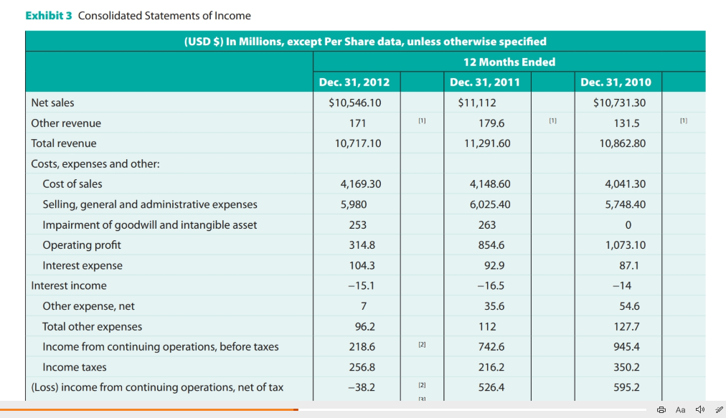

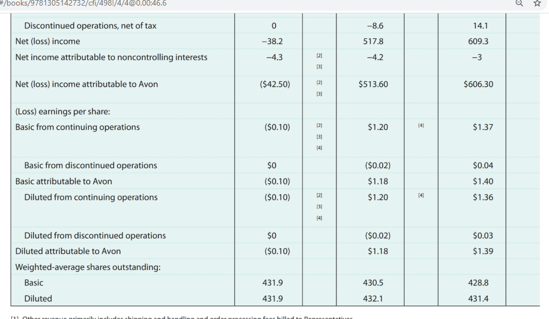

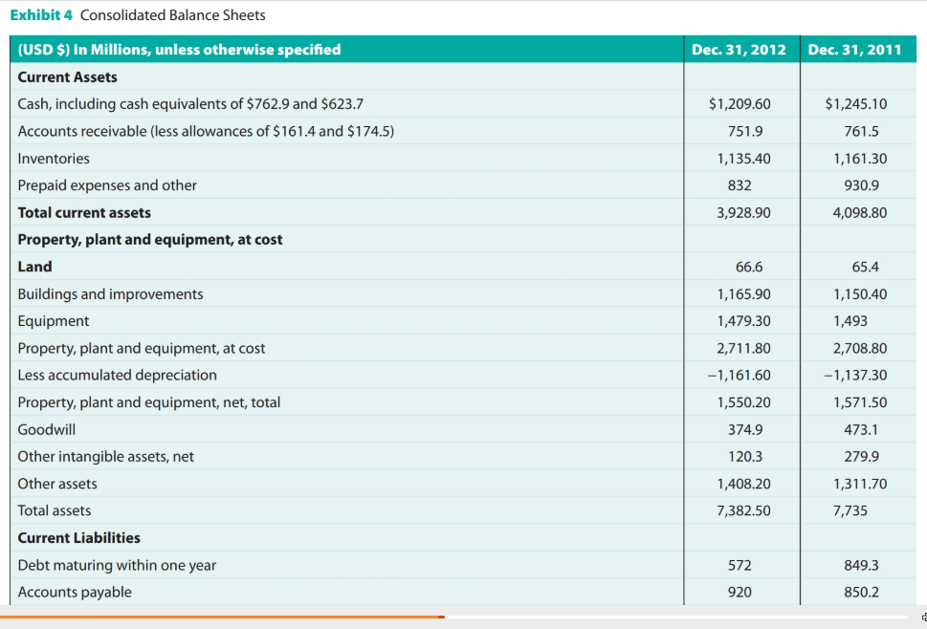
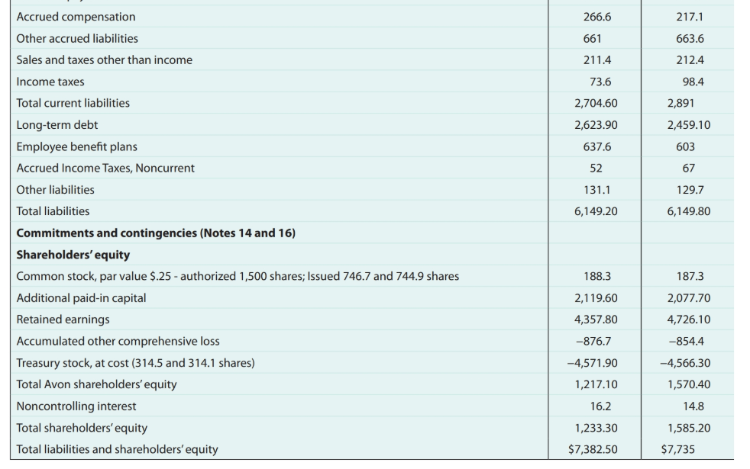

tune of $400 million. The plan also included a commit- ment to invest $200 million “to update its information systems, embrace digital and social media as contempo- rary selling tools, stop the bleeding in hard-hit markets like the U.S. and the U.K., and push premium brands like anti-aging line Anew.”56
Challenges
Missing the Target
As the competitive environment becomes more complex and rivalries intensify, Avon faces pressure to outperform new players in the market while maintaining its leader- ship among existing competitors. With large diversified companies expanding their portfolios and entering the market as direct competitors, Avon chose to focus on its tried and true products – beauty and skincare. The prob- lem occurred when Avon began concentrating too much on what it was selling instead of how it was sold. This set Avon adrift from its core competencies of entrepreneur- ship, personal marketing, and direct selling – the ele- ments that make Avon what it is. Avon tried to innovate almost exclusively with the products it offered instead of trying to innovate both with the products themselves and how they were sold, and customers were supported after buying the products. Avon was compromising its competitive advantage by deviating from its strengths and uniqueness as it took on companies with the scale and scope for more efficient, diverse, and innovative production.
Additionally, rather than understanding and build- ing on Avon’s traditional style and focus, Andrea Jung, who typically dons designer suits and accessories, wanted Avon to adapt to her style and vision for the company. With experience working for Neiman Marcus, I. Magnin, and Bloomingdale’s, Jung was drawn to the allure of trying to make Avon something it is not – a high-end retail beauty company. Jung wanted to bring additional sophistication to the brand. As Avon began targeting new demographics among women, such as trendy college-aged women as well as high-end clientele, the company impaired the efforts and positioning of its representatives who were usually working women earn- ing on average less than $50,000 a year. These women typically sold Avon products on a part-time basis to a customer base that flowed from their extended network of friends, family, and associates. Because of their lim- ited reach, representatives’ clientele typically consist of women of similar status and demographics. Thus, when Avon set its sights on new segments, it did not have rep- resentatives with the experience or contacts to reach
this new customer base. Instead, Avon had to depend on increased media advertising, retail chains, and a pull marketing strategy to achieve success. Avon was try- ing to pull customers, rather than employing its proven push strategy. Implementing this new pull strategy was very costly for Avon, as “advertising spending climbed from $63.4 million in 1999 to its peak of $400 million in 2010.”57 While many firms in multiple industries con- sider push marketing outdated, it is very effective in emerging markets where Avon saw immense growth and profit potential.
Alan Kennedy, a longtime executive in the industry who worked at Avon in the 1970s and 1980s, said: “The fundamental challenge in direct selling is getting peo- ple to sell your stuff, not so much getting people to buy your stuff.”58 This idea suggests that Avon should have remained fully committed to its grassroots beginnings and maintained the direct door-to-door model that lifted the company to prominence. Rick Goings, CEO of direct-seller Tupperware Brands, worked for Avon from 1985 to 1992 and stated, “effective direct-selling compa- nies are 25 percent about the brand and 75 percent about the sales channel.”59
Revitalizing the Sales Force
As Avon tried to innovate and upgrade its products, customers started having difficulty finding products that they considered staples. Some of these items were discontinued and some were just hard to locate in a steadily growing catalog. Consumers and representa- tives alike were complaining that products were chang- ing too often and that Avon was no longer the company that they had loved. Keeping up with the ever-changing and expanding product line affected the product knowl- edge, customer service and, ultimately, the confidence of representatives. In a model where customers depend on the expertise and recommendation of the seller, Avon’s website was an inadequate substitute for a knowledge- able representative. With women’s growing presence in corporate America and Avon’s weakening corporate strategy and leadership, the opportunity and incentive that the company once offered entrepreneurial women was fading. The number of active Avon representatives in North America fell 8 percent in 2011, leaving an esti- mated 420,000 representatives in the United States.60
Those at the heart of Avon’s business model and past success – direct sales representatives – were experienc- ing a growing discontent with the company’s policies, objectives, and initiatives. They felt that the company was putting too much emphasis on recruiting new repre- sentatives instead of focusing on expanding relationships
with current and prospective customers. In addition, representatives were not happy with the increasing cost of sales materials and felt that sales commissions should be increased. These grievances made the opportunity to be an Avon sales representative less and less appealing, as evidenced by the decline of representatives.61
Improving Corporate Governance and Management Despite an impressive background and resume, many shareholders and experts felt that Jung’s profile did not align with the company’s core values and vision and that she was not the right person to lead the company. In spite of some major successes under Jung’s leader- ship, the company experienced inconsistent growth and execution. The board, likely because of Jung’s occasional home run, did not establish a proper succession plan in the event of continued performance lags. A takeover bid by fragrance company Coty provided further evidence of the firm’s questionable internal corporate governance.
Adding to its already crippling legal woes, Avon is now under investigation to determine if the board of directors failed in its fiduciary duty to act in the best inter- est of shareholders when it rejected Coty’s $10.7 billion takeover bid. While rejecting the offer may have been at least partially tied to socioeconomic wealth,ii Avon stated that it believed the offer undervalued the company. In addition to the costs associated with the rejection of the Coty offer, total legal fees attributed to the internal inves- tigation of possible violations of the FCPA with its China operations are estimated at $250 million.62
When Andrea Jung stepped down as CEO, Avon decided to separate the role of board chairman and CEO. With Jung possessing great intellect, experience, and the ability to innovate, Avon kept her as chairman in the hopes that it can exploit these qualities. Effective collaboration between Jung and McCoy could bring great value to the company and may be the foundation for turning the company around in ways that will meet stakeholders’ expectations.
Getting Back on Track
Former CEO Jung is not, of course, solely responsible for Avon’s underperformance, particularly over the last few years of her tenure. Years before she took the helm, the company was struggling to meet earnings expectations amidst a growing industry with new entrants vying for
ii. An emotional tie to a firm, usually within a family-owned or dominated company, in which the family members or owners try to maintain the identity or existence of the firm even when it may not be in the best interest of shareholders.
market share. Many competitors were able to leverage technology and economies of scale and scope to chal- lenge Avon. Diversified companies such as P&G achieve economies of scope across their different businesses and products to save costs. In addition, the firms’ large size contributes to economies of scale, helping to keep costs down. These cost-cutting advantages allow companies to offer their products at competitive prices. This leaves Avon with the challenge of matching the price premium with innovation and differentiation or maintaining value by lowering prices.
“Yes, Avon has plenty of proprietary products, but we live in a copycat world where online retailers with lean overhead can undersell Avon when it comes to main- stream beauty-care products.”63 Products are easily imi- table, but intangibles, such as 125 years of direct-selling experience, are much harder to match. This style of prod- uct offering and delivery brings value to customers in ways that online and bricks-and-mortar stores cannot. Avon’s door-to-door, direct selling model allows custom- ers to sample and buy cosmetics from the convenience of their homes. Unfortunately, the Internet has reduced the
with current and prospective customers. In addition, representatives were not happy with the increasing cost of sales materials and felt that sales commissions should be increased. These grievances made the opportunity to be an Avon sales representative less and less appealing, as evidenced by the decline of representatives.61
Improving Corporate Governance and Management Despite an impressive background and resume, many shareholders and experts felt that Jung’s profile did not align with the company’s core values and vision and that she was not the right person to lead the company. In spite of some major successes under Jung’s leader- ship, the company experienced inconsistent growth and execution. The board, likely because of Jung’s occasional home run, did not establish a proper succession plan in the event of continued performance lags. A takeover bid by fragrance company Coty provided further evidence of the firm’s questionable internal corporate governance.
Adding to its already crippling legal woes, Avon is now under investigation to determine if the board of directors failed in its fiduciary duty to act in the best inter- est of shareholders when it rejected Coty’s $10.7 billion takeover bid. While rejecting the offer may have been at least partially tied to socioeconomic wealth,ii Avon stated that it believed the offer undervalued the company. In addition to the costs associated with the rejection of the Coty offer, total legal fees attributed to the internal inves- tigation of possible violations of the FCPA with its China operations are estimated at $250 million.62
When Andrea Jung stepped down as CEO, Avon decided to separate the role of board chairman and CEO. With Jung possessing great intellect, experience, and the ability to innovate, Avon kept her as chairman in the hopes that it can exploit these qualities. Effective collaboration between Jung and McCoy could bring great value to the company and may be the foundation for turning the company around in ways that will meet stakeholders’ expectations.
Getting Back on Track
Former CEO Jung is not, of course, solely responsible for Avon’s underperformance, particularly over the last few years of her tenure. Years before she took the helm, the company was struggling to meet earnings expectations amidst a growing industry with new entrants vying for
ii. An emotional tie to a firm, usually within a family-owned or dominated company, in which the family members or owners try to maintain the identity or existence of the firm even when it may not be in the best interest of shareholders.
market share. Many competitors were able to leverage technology and economies of scale and scope to chal- lenge Avon. Diversified companies such as P&G achieve economies of scope across their different businesses and products to save costs. In addition, the firms’ large size contributes to economies of scale, helping to keep costs down. These cost-cutting advantages allow companies to offer their products at competitive prices. This leaves Avon with the challenge of matching the price premium with innovation and differentiation or maintaining value by lowering prices.
“Yes, Avon has plenty of proprietary products, but we live in a copycat world where online retailers with lean overhead can undersell Avon when it comes to main- stream beauty-care products.”63 Products are easily imi- table, but intangibles, such as 125 years of direct-selling experience, are much harder to match. This style of prod- uct offering and delivery brings value to customers in ways that online and bricks-and-mortar stores cannot. Avon’s door-to-door, direct selling model allows custom- ers to sample and buy cosmetics from the convenience of their homes. Unfortunately, the Internet has reduced the amount of value this model creates for today’s custom- ers. Moreover, online warehouses and drugstores that can keep their costs and prices low by reducing overhead are offering lower-priced beauty products, forcing Avon to reevaluate its own costs and price structures.64 “We have to continue to look at how we make direct selling more mod- ern in some ways,” including using technology to amplify the social connections forged by the representatives.65
Avon does not have the size or capital to match retail giants and consumer goods competitors such as P&G when it comes to media advertising and marketing. Its strength is in relationship advertising and marketing. Making marketing a line function with its customer- facing representatives reduces Avon’s dependency on media marketing and thus, reduces costs.
Taking Action
As mentioned, in December 2012, McCoy announced plans to downsize by cutting 1,500 jobs and exiting from the South Korea and Vietnam markets. On April 8, 2013, Avon announced plans to downsize further by cutting 400 additional jobs and restructuring or abandoning opera- tions in Africa, the Middle East, and Europe, including exiting from Ireland, as it aims to save $400 million by the end of 2016.66
in the high-priority foreign markets, such as Brazil and Russia, where profits started declining in 2010 and 2006, respectively. Cultural needs and preferences pose challenges for the company as it competes with local competitors for market share. While Avon products are generally standardized, different cultures and ethnici- ties have different needs and wants from its products. Because of the high growth potential in these emerging markets, Avon cannot afford to abandon them or reduce its reps as suggested by its cost-cutting initiatives. When Avon moved to a global strategy under Andrea Jung in order to standardize and improve controls and coor- dination, the company suffered in its ability to opti- mize local responsiveness. Remote management cou- pled with increased competition and changing needs, have led to Avon’s stalled sales in Brazil and Russia.68 Recently, Avon took steps to better meet the needs of its local markets by introducing products that match the preferences of the customers there. First quarter 2013 results show a 10 percent and 3 percent sales increase in Brazil and Russia, respectively, proving this response was effective.69
Conclusion
Avon’s long history is attributed to its unique approach to meeting the needs of women. Today, “Avon markets leading beauty, fashion, and home products to women in more than 100 countries through more than 6 million active independent Avon Sales Representatives.”70 This vast market requires the company to be in tune with what women all around the world want. Avon’s continued
success depends on its ability to effectively identify and meet the ever-changing needs and preferences of the women it serves both internally and externally – as repre- sentatives and consumers. As time constantly welcomes change in the external environment and competitive landscape, Avon must find a way to sustain its unique approach and core competencies. With looming pres- sures to innovate, outperform competitors, yield expected earnings, and ensure future profitability, Avon should not stray from the foundation of direct selling that brought it success. However, it must modernize the direct selling model to enhance its ability to create value for customers not only today, but “tomorrow” as well. Different markets must be matched with local responsiveness and cultural understanding and adaptability. Ethical concerns and moral hazards must be matched with corporate gover- nance and value alignment. Competitive rivalry must be matched with innovation, effective leverage, and execu- tion of core competencies. Developing and then using strategies that blend appropriately with the firm’s vision and mission is critical to the firm’s success. Risks must be matched with calculated and controlled growth and diversification. The combination of each individual chal- lenge makes up the daunting task of returning Avon to its previous greatness, a responsibility falling on the new CEO’s shoulders. Is CEO Sheri McCoy the right match for the challenge?” More specifically, is she the strategic leader who can work with others to find ways to facilitate Avon’s efforts to create value for all stakeholders and per- haps especially for shareholders? Is the plan she is putting into place going to lead to the turnaround at Avon that many believe is necessary?
While abandoning some foreign markets will cut costs, 83 percent of the company’s revenue comes from outside of North America.67 Therefore, Avon’s future success depends on its ability to efficiently meet demand

