Solicited Proposals
In this case, the business, agency, or organization seeking proposals has already iden- tified a situation or problem it wants to address. Accordingly, it issues a request for proposal (RFP) that spells out the details of the project and provides instructions to outsiders for submitting bids. Many RFPs are quite lengthy and complex. They appear in trade publications, as government releases, and on the Internet. An individual or organization wishing to compete for a particular contract must craft a proposal that convincingly demonstrates its superiority to the many others received.
In one sense, however, responding to an RFP is easier than writing an unsolicited proposal because the problem or goal has already been established and there is no need to convince anyone of its existence or importance. In addition, the RFP usually provides explicit instructions regarding the format, design, and content of the pro- posal, so those requirements—which must be followed exactly—are already in place.
Unsolicited Proposals
In this case, the proposal originates with the writer, who has perceived a problem or need that the writer’s expertise might be able to remedy. Although an unsolicited proposal may face no direct competition, it’s more challenging to compose because it must convince the reader of the potential benefits. In short, it must be more stra- tegically persuasive than a solicited proposal, whose acceptance or rejection is often based largely on cost and time projections as well as the writer’s credentials and expe- rience on similar projects—all of which is fairly objective information.
Internal and External Proposals
As with most other kinds of business writing, a proposal—solicited or not—may be either an in-house document or an external one.
Internal proposals: These are often rather short because the writers and read- ers are already known to each other and the context is mutually understood. Solicited in-house proposals are not usually written in response to a formal RFP but rather to a direct assignment from a manager, supervisor, or other administrator. Unsolicited in-house proposals are motivated by an employee’s own perception of need—for example, the belief that a particular policy or procedure should be adopted, modi- fied, or abandoned.
External proposals: As mentioned previously, solicited external proposals are nearly always in response to formal RFPs, but unsolicited external proposals—which are more difficult to create—obviously are not. External proposals are motivated pri- marily by the desire for financial reimbursement. In effect, they might almost be considered as a form of employment application.
Formats of Proposals
If in-house, short proposals usually take the form of a memo, e-mail, or memo report; if external, they are typically sent as a letter. Longer, more fully developed proposals can include many sections (they closely resemble long reports) and are sometimes written collaboratively (see Chapter 11).
Objectives of Proposals
Regardless of whether a proposal is solicited or unsolicited, internal or external, short or long, it should accomplish several objectives, some of which may overlap:
• Clearly summarize the situation or problem that the proposal is addressing. If unsolicited, the proposal must convince the reader that there is in fact an important unmet need.
• Provide a detailed explanation of how the proposal will correct the situation or problem. This is sometimes called the project description, and it typically contains several parts.
• Confirm the feasibility of the project and the anticipated benefits of completing it, as well as possible negative consequences of not doing so.
• Convincingly refute any probable objections.
• Establish the writer’s credentials and qualifications for the project.
• Identify any necessary resources, equipment, or support.
• Provide a reliable timeline for completion of the project. A Gantt chart (see Chapter 3) is sometimes used for this.
• Provide an honest, itemized estimate of the costs. Deliberately understating the timeline or the budget is not only unethical (see Chapter 1) but also fraudulent. Doing so can incur legal liability.
• Close with a strong conclusion that motivates the reader to accept the proposal. A convincing cost/benefit analysis is helpful here.
As mentioned in earlier chapters, workplace communications must always be sensitive to considerations of audience, purpose, and tone. This is especially impor- tant in proposal writing because of its fundamentally persuasive nature. A proposal writer must be alert to the differing requirements of upward, lateral, downward, and outward communication. The phrasing should be reader-centered, using the “you” approach. And because by definition proposals seek to improve conditions by rec- tifying problems, it’s important that they remain positive and upbeat in tone. The writer must refrain from assigning blame for existing difficulties and should instead focus on solutions. This is especially important when writing in-house, where a hos- tile climate can result if the writer neglects to consider people’s needs and feelings
particularly if the proposal’s recommendations might alter or otherwise affect the responsibilities of coworkers or departments.
Like any workplace document, a proposal is far more likely to succeed if well-written. Nothing tarnishes credibility more quickly than careless typos and basic errors in spelling, punctuation, or grammar. In addition, workplace writ- ing should always be accurate, clear, and well-organized. The wording should be simple, direct, and concise, using active verbs and everyday vocabulary, with no rambling, wordy expressions. The crucial point to remember is that no amount of study from a textbook will enable you to compose your best writing on the first try. Any professional writer will tell you that the key is to revise, revise, and revise. Finally, proofread carefully.
In addition, a proposal should look inviting. As explained in Chapter 4, our abil- ity to comprehend what we read is greatly influenced by its physical arrangement on the page or screen. When we see a document we form an involuntary subconscious opinion of it before we begin to actually read. Obviously, a positive initial impres- sion goes a long way toward fostering a more receptive attitude in a reader. There- fore, strive for a visually appealing page design by applying the principles outlined in Chapter 4.
Figures 10.1–10.20 present several sample proposals: • From a student to her instructor regarding a topic for her long report assignment
• From an employee to her supervisor regarding improvements to the company’s day care facilities
• From a landscaping company to a real estate agency regarding improvements to the agency’s grounds
• From a community group to a philanthropic agency regarding the restoration of a trail system

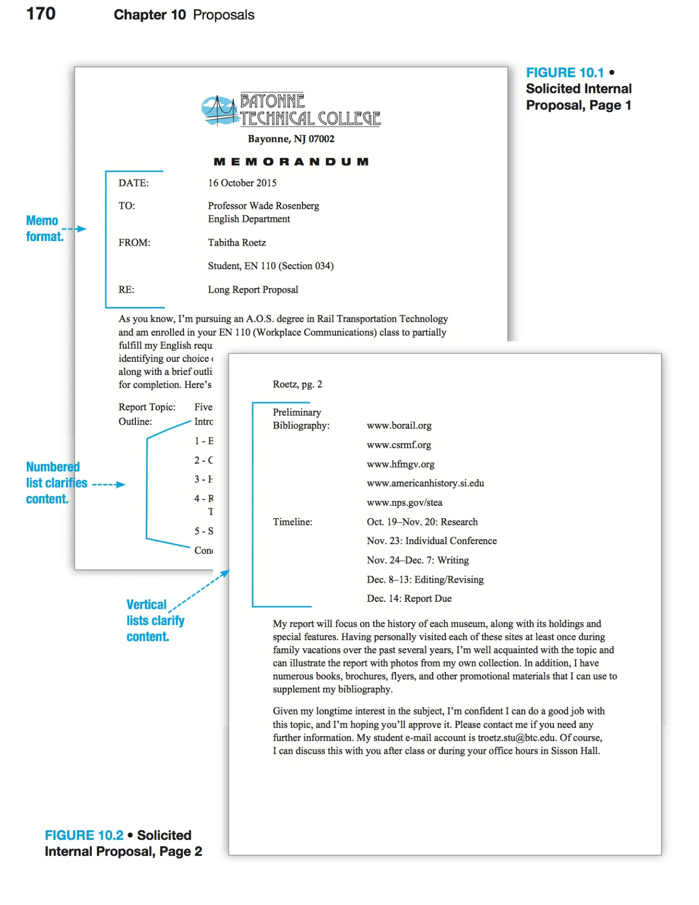

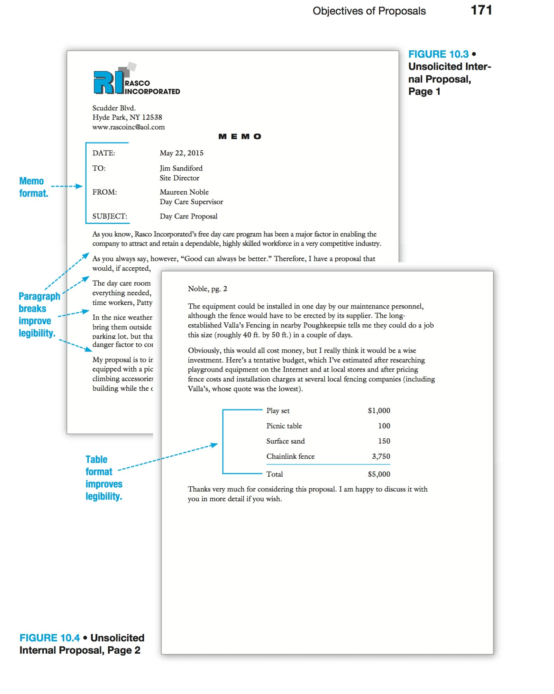

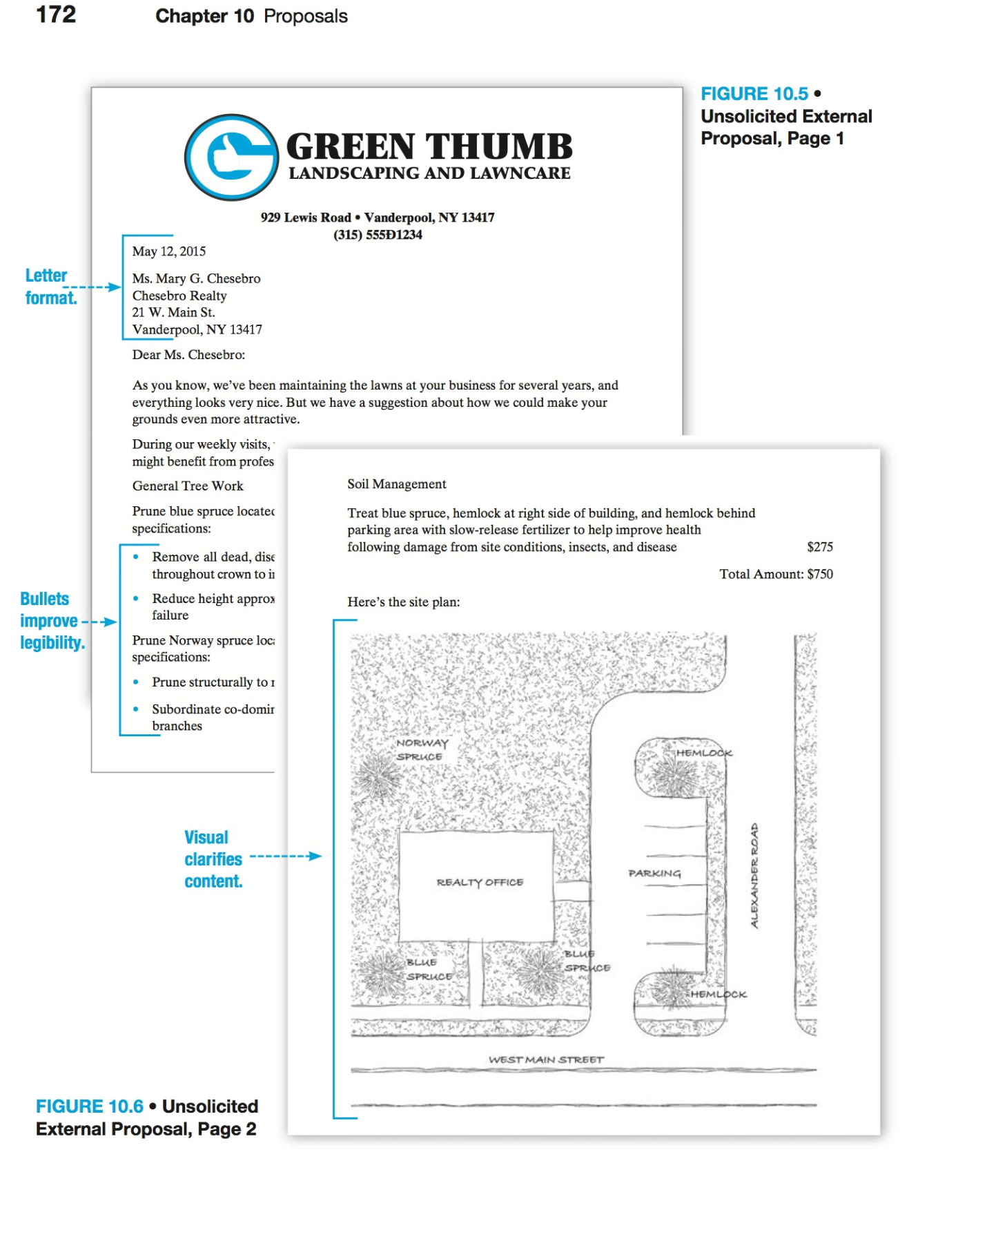

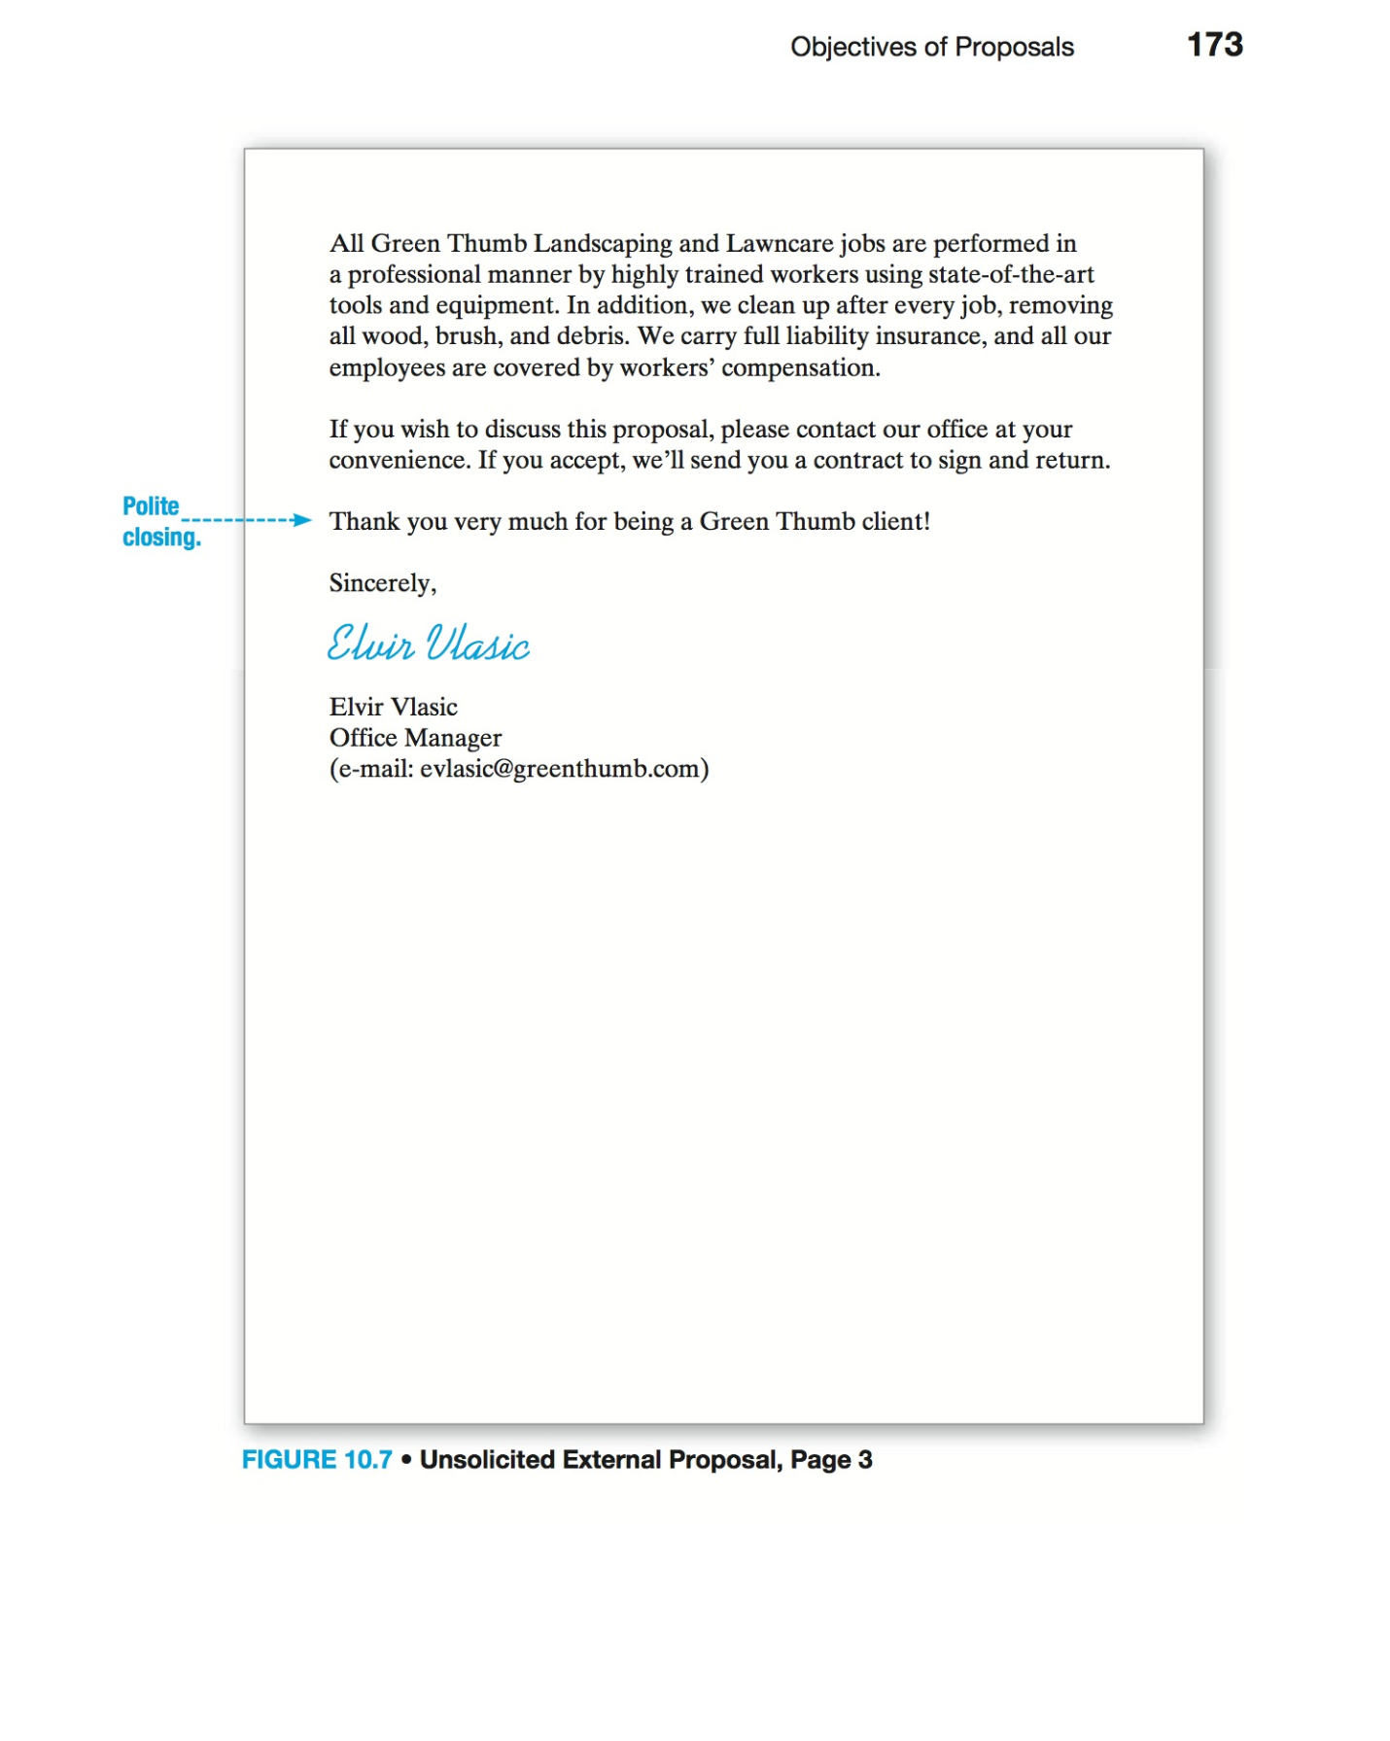

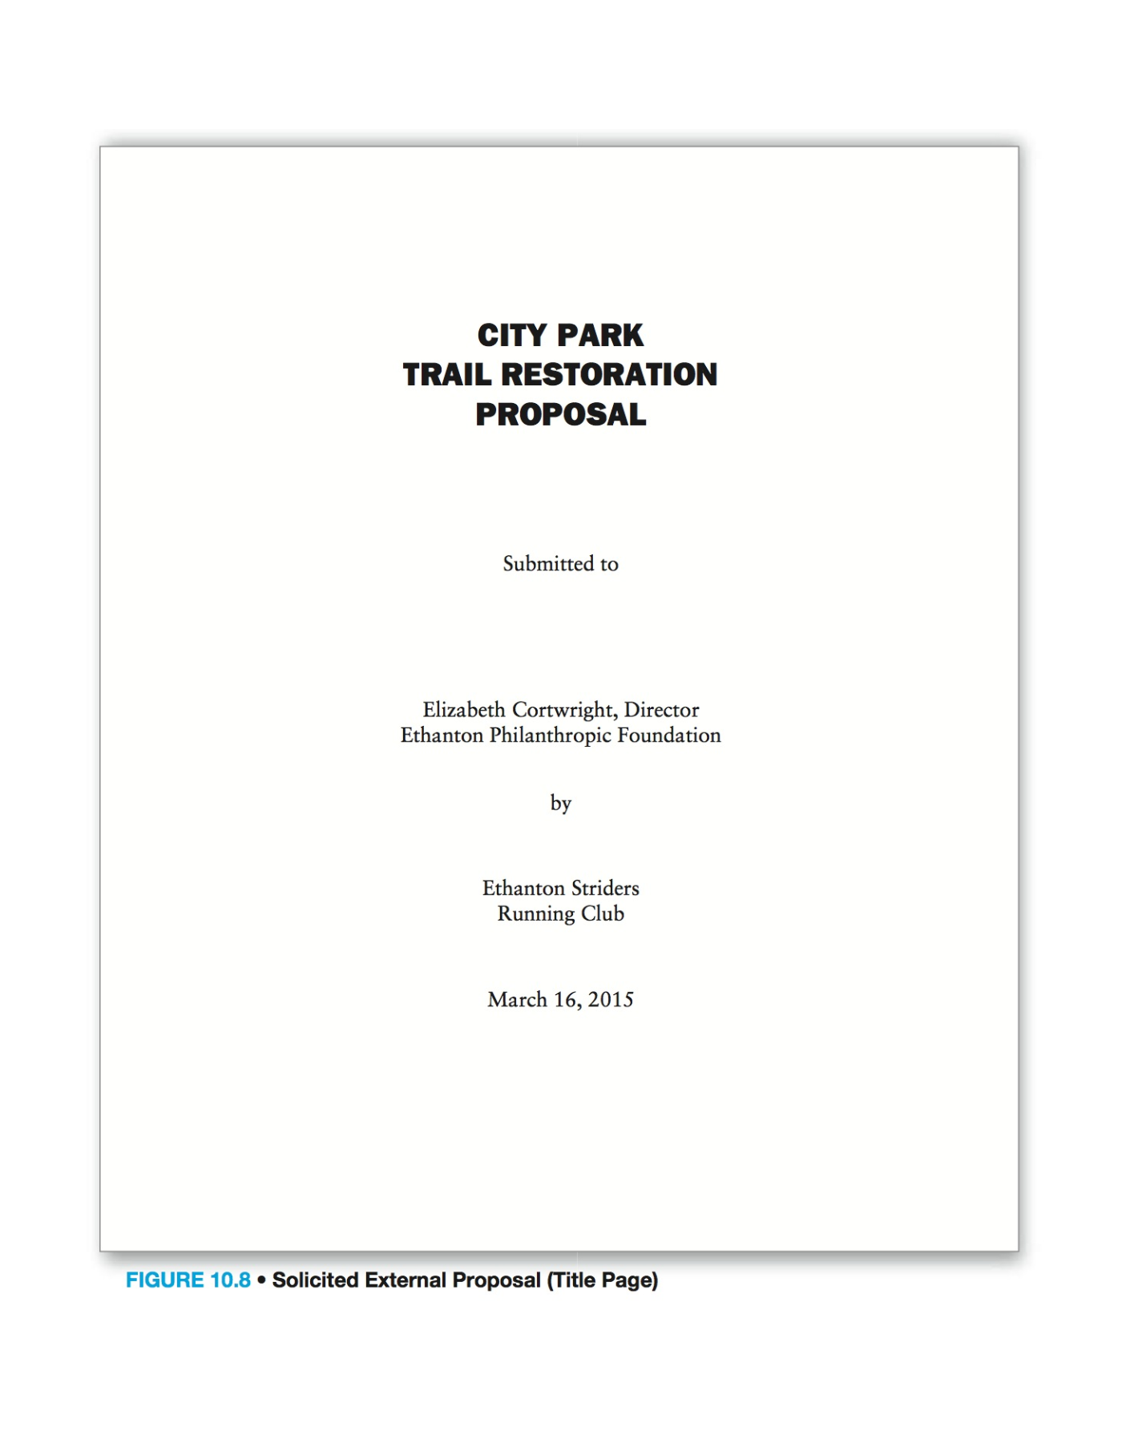

CONTENTS
Project Summary ........................................................................................................ 1
Project Description
Phase 1.............................................................................................................. 1
Phase 2.............................................................................................................. 2
Phase 3.............................................................................................................. 2
Rationale.................................................................................................................... 2
RFP Criteria ................................................................................................................ 3 Timeline..................................................................................................................... 5 Budget........................................................................................................................ 6
Ethanton Striders Board of Directors ......................................................................... 7
Conclusion ................................................................................................................ 8
Appendices
Figure 1 - Blowup of Gate Area.......................................................................... 8
Figure 2 - Sign Detail......................................................................................... 9
Figure 3 - Sketch View of Main Gate ................................................................. 9
Figure 4 - Site Plan .......................................................................................... 10
Figure 5 - Mayor’s Endorsement ..................................................................... 11

PROJECT SUMMARY
For several years the Ethanton Striders Running Club has been formulating plans to rehabilitate the deteriorating footpath in the wooded area of Ethanton City Park. The project will involve three phases. At this point we are requesting a matching grant of $20,000 from the Foundation to complete the first part of the project, which includes enhancement of the entrance to the woods, in part by installing gates and repaving the roadway. Funding for the second and third parts of the project will be sought from other nongovernmental sources.
PROJECT DESCRIPTION
Originally a carriage path, the present trail took shape as a Works Progress Administration (WPA) project during the Great Depression and enjoyed considerable popularity until fairly recently. Now, however, natural deterioration has taken its toll and the trail is endangered. Broken culverts and clogged drainage ditches have allowed water runoff to erode the trail, and in many places the road surface is badly damaged. In short, potentially unsafe conditions are inhibiting full use of the trail and may eventually cause it to be closed.
The Striders are committed to preventing this because we see the trail as an important community resource that must be protected. We envsion a return to the trail’s former diverse-use status. We want the trail to remain a resource for running and other outdoor sports, but we are hopeful that the proposed improvements will also afford a broad range of other nonmotorized leisure opportunities as well.
As mentioned previously, we envision a three-part plan:
Phase One
• Creating a defining entrance vista and increased visibility; improving security of pavilion area by landscaping, tree and brush removal, and signage
• Installing two locking gates—one near the pavilion and one below—to restrict vehi- cle access while allowing pedestrian access
• Improving drainage provisions above and near the pavilion
• Upgrading of existing pavilion parking area
• Resurfacing of roadway leading to the entrance

Phase Two
• Replacing and backfilling fifteen unsalvageable drainage culverts
• Cleaning out and repairing seven additional salvageable culverts
• Boxing out and grading area around all twenty-two culverts
• Placing 2 inches of Type 3 binder to stabilize area around all twenty-two culverts in preparation for paving trail
• Cleaning out drainage ditches alongside trail
Phase Three
• Installing riprap (filler stone) to inhibit water runoff
• Applying two layers of surfacing—a base and a covering of fine stone mixed with rolled petroleum slurry—all along the trail
• Paving entire 2 miles (10,560 linear feet) of trail, 8 feet across, with 1/2 inch of true and 1 inch of top macadam
RATIONALE
This project is currently the Striders’ top priority for several reasons. A not-for- profit citizens’ organization, we are dedicated to promoting physical fitness through running, and the trail plays a significant role in that endeavor. It comprises a major part of the annual Autumn Leaves 10k Roadrace course, and of the summer Thursday Training Runs course as well. The Autumn Leaves is a premier competitive running event and was recently featured in an article in Runner’s Times magazine. Attracting participants from all over the Northeast, the Autumn Leaves pumps many thousands of dollars into the local economy the second weekend of every October. The family-oriented Thursday Training Runs are a long-established, ongoing series of weekly “fun runs” enjoyed by hundreds of local participants on twelve consecutive Thursday evenings during the months of May, June, and July.
But the importance of our project extends far beyond these two events because the City Park trail is used year-round for a wide variety of non-vehicular recreational activities: hiking, bicycling, bird-watching, cross-country skiing, snow-shoeing, and the like. The Striders believe that the project will foster positive and significant changes n the community, ones that identify and enhance local strengths and that focus on identifiable outcomes that will make a difference. Our goals are quite clearly defined and—if achieved—will certainly impact most favorably on the quality of life here in Ethanton. Now that the area is undergoing something of a revitalization, we wish to contribute an additional dimension by championing a renewed commitment to one of our city’s most valuable resources—the City Park Trail.
RFP CRITERIA
The Ethanton Philanthropic Foundation’s RFP includes specific criteria by which each proposal will be judged. What follows is a point-by-point response to these parameters.
Describe the degree to which the project provides for enhanced public enjoyment of outdoor amenities in the greater Ethanton area.
Despite its deteriorated condition, the City Park Trail is used on a year-round basis. It is used primarily for running, hiking, and bicycling during the nonwinter months of April through October. From November through March, the trail is used by cross- country skiers and snowshoers. The trail is central to the Thursday Training Runs series from May through July, to the annual Autumn Leaves 10k Roadrace every October, and to several other fund-raising running events. Our proposal will ensure that these activities continue without fear of injuries caused by poor footing or surface conditions. In addition, the project will again provide the high school cross- country ski and running teams with a natural training site entirely within city limits. Until recently the school had used the trail in this way, but for the past three years school officials have considered the trail too unsafe. This has forced the ski team to travel to Little Davos Mountain (some 15 miles away) to practice, creating added expense.
Describe the degree to which the project furthers a specific goal of state, regional, or local planning bodies.
The Ethanton City Council has officially identified the City Park Trail problem as a high-priority issue. The Striders Board of Directors has been working closely with the Mayor’s office about this, and we have received assurances of full cooperation.
(See Appendix.) Indeed, at least some of the work involved will almost certainly be performed pro bono by Ethanton Parks Department personnel.
Specify the project’s Index of Need (statistically driven rating assigned by Regional Grants Office).
The Regional Grants Office has assigned a preliminary rating of 78.
Describe the degree of citizen involvement in project conception and implementation.
The project is under the direction of the Ethanton Striders Running Club, a 200+ member not-for-profit citizens’ organization whose mission is to promote health and fitness through running. Other citizens’ groups from the greater Ethanton area have committed resources toward the completion of the project. Members of the Striders will provide project administration and supervision. In addition, a volunteer group consisting of employees of a large local business will provide equipment and operators for much of the tree removal, drainage ditch clearing, and drainage restoration. As mentioned previously, it is expected that additional assistance (engineering and oversight) will be provided by the City Parks Department.
Describe the degree to which the project relates to other Ethanton-area initiatives (natural, cultural, historical, or recreational).
City Park, located entirely within Ethanton city limits, is a large recreation area comprising a pavilion, a nine-hole municipal golf course, tennis courts, and playing fields. Until its deterioration, the trail through the wooded area was an integral part of this multi-use park. It is our intention to restore the trail to provide a safe environment for runners, hikers, bicyclists, cross-country skiers, and snowshoers, thereby promoting greater citizen enjoyment of the natural world. The trail in question connects to other park roads, which are currently shared-use roadways for nonmotorized and motorized access to park facilities.
Describe the degree to which volunteer labor, nontraditional labor, and other certified donations will be used to accomplish the project’s goals.
At least three area citizens’ organizations, the Striders included, have committed resources to the completion of the trail restoration project. Two of the three will provide a considerable amount of volunteer labor and equipment. The third organization has committed up to $20,000 in financial support, pending approval of this proposal by the Ethanton Philanthropic Foundation. In addition, the Striders are able to call upon an extensive list of volunteers who have signed up to help during other club-sponsored initiatives. A community service group affiliated with a large local corporation will supply heavy equipment and operators for much of the work.
Describe the impact the proposal will have on the cultural, social, and recreational needs of the region.
As mentioned in several other parts of this proposal, the trail restoration project is specifically designed to serve the recreational needs of the region by ensuring the continuation of the Thursday Training Runs, the Autumn Leaves Roadrace, and other community-oriented running events. In addition, successful completion of the project will greatly enhance the opportunities for recreational running, hiking, cross- country skiing, bicycling, and snow-shoeing. And restoration of the trail will permit its use by the Ethanton High School cross-country ski and running teams. In addition, we expect that the refurbished trail will invite use by bird-watchers and other nature lovers as part of the existing system of interlocking trails within the park.
TIMELINE
Obviously, any scheduling projections for a project of this scope must be tentative at best because the project depends on several variables including funding and weather. The Striders are hoping to secure adequate financing through a variety of means (see Budget section of this proposal), but this may take longer than expected. In addition, the Vermont winters certainly preclude any progress during that season, leaving only the spring and fall seasons to complete work (we hope to keep the trail open for use during the summer). What follows, then, is a very optimistic timeline. We will make every effort to stay on schedule, but we realize that full completion of the project may take somewhat longer than planned.

